Module 1 – Cellular Control

2.1.1 How DNA codes for proteins

What is a gene? | What is a gene?
What is a gene? | How many genes are in the human genome?
What is a gene? | What is the place that a specific gene occupies on the genome called?
What is a gene? | What is a histone?
What is a gene? | Name four polypeptides coded for by genes. | 1. | 2. | 3. | 4.
The genetic code | What is meant by a triplet code?
The genetic code | How many amino acids are used for protein synthesis?
The genetic code | What is meant by a degenerate code?
The genetic code | What else other than amino acids can a triplet code for?
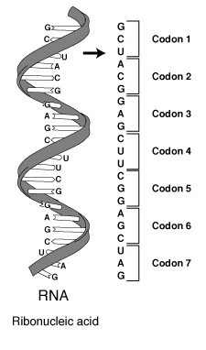
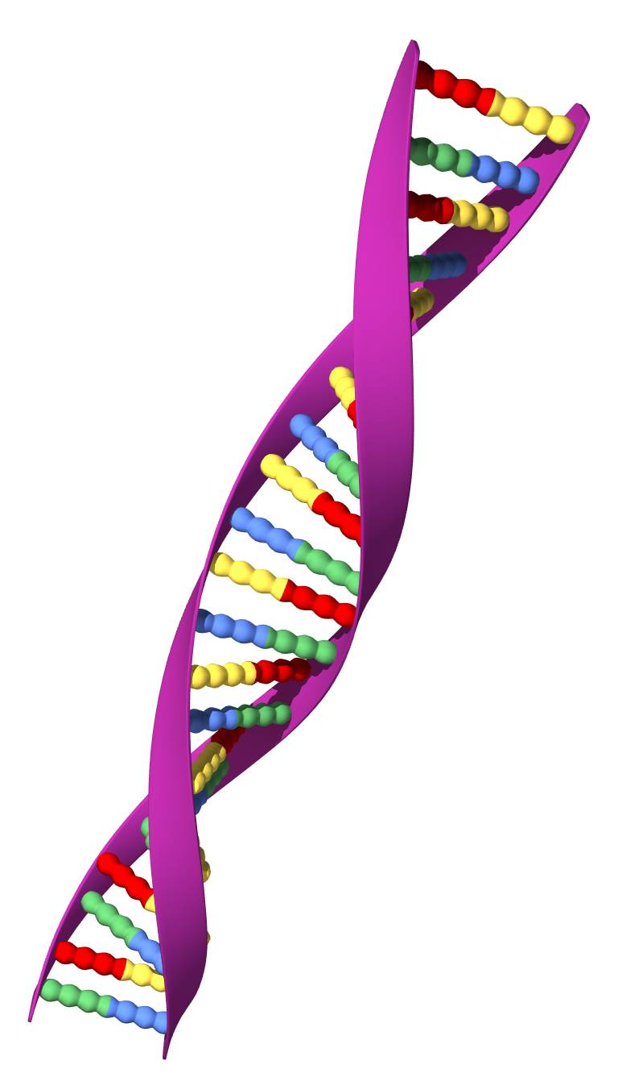

How do nucleotide sequences code for amino acid in a polypeptide? | Where are proteins assembled?
 | What passes the genetic code to the cytoplasm?
 | What is the first stage of protein synthesis?
 | Define transcription
 | What are the two strands of DNA called? | 1. |  | 2.
 | What are the four activated RNA nucleotides? | 1. | 2. | 3. | 4.
 | What must happen for the two DNA strands to unwind?
 | Complete the table:
  DNA base | A |  |  | C
  Complementary DNA base |  | C
  Complementary RNA base |  |  | A
 | Which enzyme catalyses the bonding of complementary bases?
 | Which DNA strand is complementary to the messenger RNA (mRNA)?
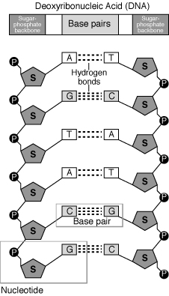
2.1.2 Translation

Introduction | Translation is the second stage of what?
Introduction | Define translation
Introduction | What is a codon?
Introduction | Where can ribosomes be found? | 1. |  | 2.
Ribosomes | What are the constituents of ribosomes? | 1. |  | 2.
Ribosomes | What determines a protein’s tertiary structure?
Ribosomes | What holds a protein in its tertiary structure? | 1. | 2. |  | 3.
Ribosomes | What can happen if the tertiary structure of a protein is altered?
Transfer RNA | What allows transfer RNA (tRNA) to bind to messenger RNA (mRNA)?
Transfer RNA | What binds to the other end of the tRNA?
How the polypeptide is assembled | How many codons are attached to the small ribosomal subunit?
How the polypeptide is assembled | What is always the first mRNA codon? What does it code for?
How the polypeptide is assembled | What forms between the adjacent amino acids?
How the polypeptide is assembled | How many tRNA can bind to the ribosome at one time?
How the polypeptide is assembled | What are UAA, UAC and UGA? What is special about them?
How the polypeptide is assembled | What molecule do some proteins require to become active?
How the polypeptide is assembled | How does cyclic AMP activate proteins?
Protein synthesis in prokaryotes | What differs between eukaryotic and prokaryotic translation? Why?

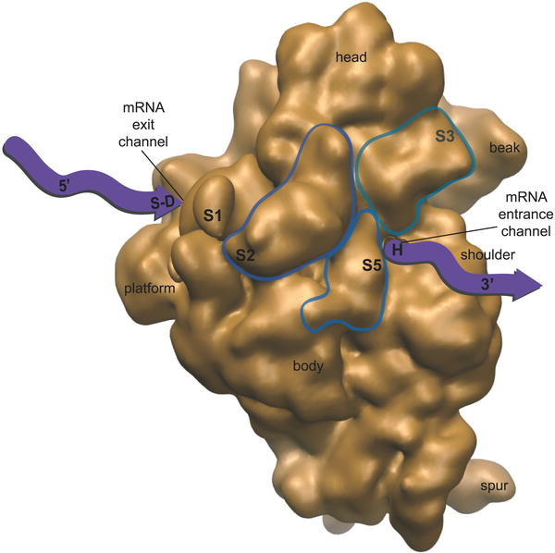
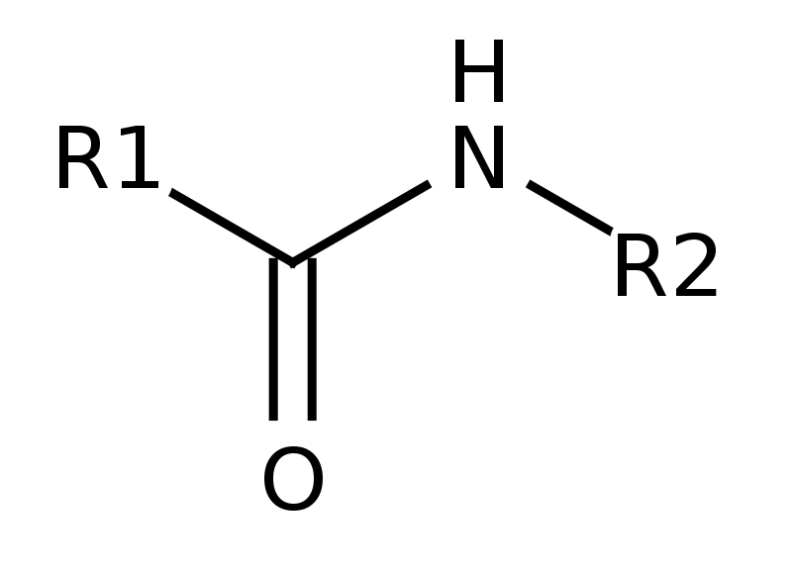

2.1.3 Mutations – 1
What is a mutation?
Define chromosome mutation.
Give three examples of mutagens. | 1. | 2. |  |  | 3.
What is altered in a DNA mutation?
Complete the table about DNA mutations by putting yes (y) or no (n) in the correct squares.
  Mutation occurring in: | Somatic mutation (y/n) | May lead to cancer  (y/n) | Can be inherited  (y/n)
  Mitosis
  Meiosis
What are the two main classes of DNA mutation? | 1. |  | 2.
Draw a diagram to explain frameshift. What may happen to the amino acids which are coded for by the triplet codes?
Why are frameshift mutations so destructive to proteins?
Name two diseases which are the result of DNA mutations. | 1. |  |  | 2.
Why after a point mutation may there be no change at all in amino acid sequence?
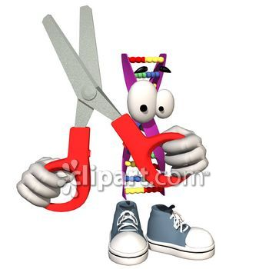
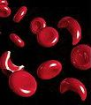
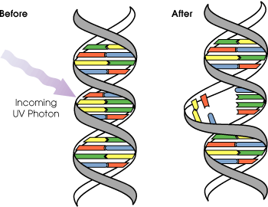

2.1.4 Mutation – 2
Mutations with neutral effects | What is an allele?
Mutations with neutral effects | When will a different allele produce no change to the organism? | 1. | 2.
Mutations with neutral effects | When is a mutation neutral?
Mutations with harmful or beneficial effects | Are all mutations that are not neutral harmful to the organism?
Mutations with harmful or beneficial effects | Give an example of a beneficial mutation on this double page spread.

Quick Quiz 1 – Sections 2.1.1 to 2.1.4
?

1. Match the terms to their definitions.

1. Gene |  | A mutation in which one base pair replaces another
2. Polypeptide |  | The assembly of polypeptides at ribosomes
3. Transcription |  | A length of DNA coding for a polypeptide
4. Translation |  | An alternative version of a gene
5. Point mutation |  | A polymer consisting of a chain of amino acids
6. Allele |  | The creation of a single-stranded mRNA copy of the DNA coding strand

2. Complete the table of triplet codes:

DNA coding strand |  |  |  | TTA
DNA template strand | TAC
mRNA |  | AGC | UAC

3. Name and describe the roles of the three different RNA molecules involved in transcription and translation.

1.

2.

3.

2.1.5 The lac operon
Introduction | What is enzyme induction?
Enzyme induction | Complete the sentences. | Basic cellular function ______________ are synthesized at a relatively ______________ rate. ______________ enzyme synthesis varies according to ______________. Enzymes produced by E. coli to allow it to metabolise lactose are examples of ______________ enzymes; these enzymes are ______________________ and ______________ ______________.
Enzyme induction | Lactose is hydrolysed to what?
Enzyme induction | What happens a short time after lactose is added to a culture containing E. coli?
Enzyme induction | What acts as the inducer?
Lac system genes form an operon | Draw the lac operon, label the main regions and give their function (do not include the regulatory region).
How the lac operon works | What stops RNA polymerase binding to the promoter region?
How the lac operon works | What causes the repressor region to no longer inhibit transcription of the structural genes?
How the lac operon works | Where does lactose bind in this system?
How the lac operon works | Are all E. coli strains bad? Give an example where they are useful.
How the lac operon works | Is the repressor protein coded for in the lac operon?

2.1.6. Genes and body plans
Drosophila development | How often are the mitotic divisions after Drosophila eggs are laid?
Drosophila development | How many segments merge to produce the head section?
Drosophila development | Define homeobox genes.
Drosophila development | Maternal effect genes determine what?
Drosophila development | What type of genes specify the nature of each of the body segments?
Genetic control of development in other organisms | How many base pairs are there in each homeobox gene?
Genetic control of development in other organisms | What is a Hox cluster?
Genetic control of development in other organisms | In what order are homeobox genes activated?
Genetic control of development in other organisms | What can happen if a pregnant woman has too much retinoic acid?

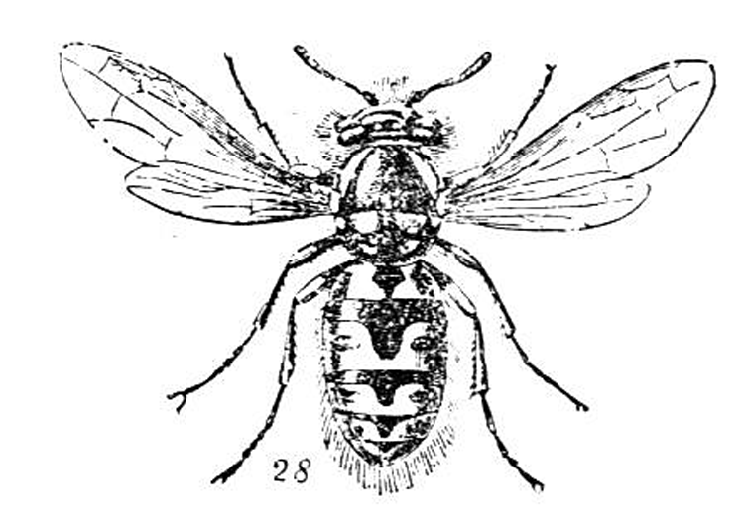

2.1.7. Apoptosis
Introduction | Define apoptosis.
The sequence of events | Complete the flow diagram to show the stages of apoptosis. | Cell cytoskeleton broken down by enzymes
The sequence of events | What molecules act as cell signals for apoptosis? Name four. | 1. | 2. | 3. | 4.
Apoptosis and development | Give two examples why apoptosis is better than necrosis during tissue development. | 1. |  | 2.
Apoptosis and development | What two problems are caused by improper apoptosis? | 1. |  | 2.
Apoptosis and development | Give an example of where apoptosis happens in normal human development.
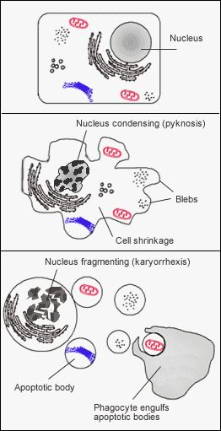
2.1.8 Meiosis
 | Match the definition to the term.
  A. Haploid | Fusion of two gametes
  B. Gamete | A reduction division
  C. Meiosis | Reproductive cell from parent
  D. Zygote | Have half the original chromosome number
 | After meiosis the chromosome number is…? (Circle the correct answer.) | Doubled Stays the same Halved Quartered
Meiosis I | When homologous chromosomes come together in prophase I they are known as?
Meiosis I | What is crossing over?
Meiosis I | Give three other events that happen in prophase I. | 1. | 2. | 3.
Meiosis I | What is the main event in anaphase I?
Meiosis I | What is the final stage of meiosis I?
Meiosis I | Where do the spindle fibres originate from?
Meiosis I | Where in the cell are the centrioles positioned during meiosis I?
Meiosis I | In animal cells does the cell membrane reform around each cell?
Meiosis I | What is the process called where cells divide physically into two?
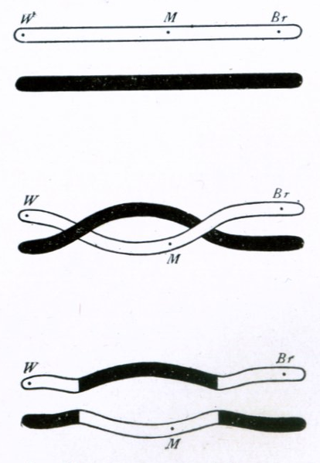
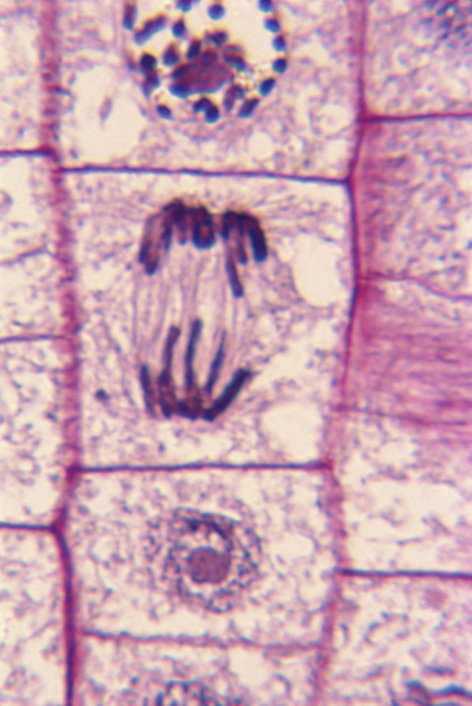

Meiosis II | Match the description to the phase of meiosis II.
  A Prophase | Chromosomes arranged on equator of the spindle
  B Metaphase | Nuclear envelope reforms
  C Anaphase | Nuclear envelope breaks down, nucleolus disappears
  D Telophase | Centromeres divide, chromatids pulled to poles
Meiosis II | In which phase of meiosis I and II are the centrioles not present?
Meiosis II | In which phase of meiosis (I or II) do the centromeres divide?

2.1.9 The significance of meiosis
Introduction | How does meiosis produce genetic variation?
Introduction | What is an allele?
Introduction | What is a locus?
Introduction | Is a zygote haploid or diploid?
How meiosis and fertilisation lead to genetic variation | Give two places where genetic variation increases during meiosis. | 1. |  | 2.
How meiosis and fertilisation lead to genetic variation | What is chiasmata?
How meiosis and fertilisation lead to genetic variation | Regarding crossing over which statement is true? | During crossing over, different genes coding for different proteins are swapped
How meiosis and fertilisation lead to genetic variation | Regarding crossing over which statement is true? | During crossing over, different alleles of the same gene are swapped
How meiosis and fertilisation lead to genetic variation | True or false? | At anaphase I all the paternal chromosomes move to the same pole
How meiosis and fertilisation lead to genetic variation | How does fertilisation produce some genetic variation?
How meiosis and fertilisation lead to genetic variation | Where must a mutation occur if it is to be present in every cell in the organism?
How meiosis and fertilisation lead to genetic variation | Name four different types of chromosome mutation. | 1. | 2. | 3. | 4.
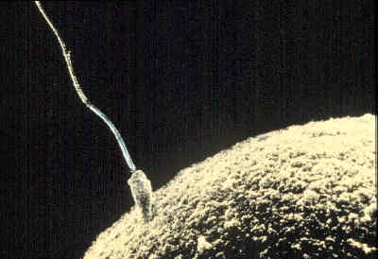
Quick Quiz 2 – Sections 2.1.5 to 2.1.9
?

1. Match the terms to their definitions.

1. Repressor protein |  | Attachment point of sister chromatids during crossing over
2. Homeobox genes |  | Prevents RNA polymerase binding to the operator region
3. Phagocytosis |  | Control the development of the body plan
4. Meiosis |  | Produces daughter cells with half the number of original chromosomes
5. Locus |  | Endocytosis of large solid molecules into a cell
6. Chiasmata |  | The position of a gene on a chromosome

2. Draw a story board to show the regulation of the lac operon by the repressor protein and give brief descriptions of the main events.

3. Fill in the gaps.

Meiosis is split into __________ parts, meiosis I and meiosis II. Each part has four stages __________, __________, __________, and __________. Meiosis is an example of sexual reproduction and this produces __________ __________. One example of this is __________ __________ during prophase I, where homologous chromosome pairs come together to form __________. Reassortment of chromosomes in and reassortment of __________ during metaphase II also increase genetic variation. Other events, which cause genetic variation are: __________ due to the huge numbers of sperm each with different DNA and mutation, and this __________ will be present in every cell in the organism if it occurs in the sperm or egg.

2.1.10 Some terms you need to know
Genotype and phenotype | Define genotype.
Genotype and phenotype | What is the difference between homozygous and heterozygous?
Genotype and phenotype | Fill in the table relating to cystic fibrosis.
  Homozygous/heterozygous | Genotype | Phenotype
  Homozygous
   |  | Some abnormal chloride channels but no symptoms
   | cfcf
Genotype and phenotype | What determines an organism’s phenotype?
Dominant and recessive | Define dominant.
Dominant and recessive | Define recessive and give an example.
Dominant and recessive | Define codominance and give an example.

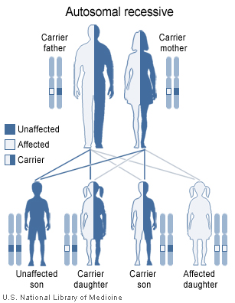

Linkage | If two genes are located on the same chromosome they are referred to as what?
Linkage | What is the significance of linkage during meiosis?
Linkage | Where are most sex-linked genes found?
Linkage | Which of these denotes that the two alleles (A/a and B/b) are linked? Circle the correct answer. | AaBb AbAb
Linkage | Homozygous round-leaved, flowering plants (RRFF) were crossed oval-leaved, non-flowering plants (rrff).  When the F₁ generation plants were allowed to self-pollinate they produced the following:  - 203 round-leaved, flowering plants  - 15 round-leaved, non-flowering plants  - 32 oval-leaved, flowering plants  - 71 oval-leaved, non-flowering plants | 1. What will the genotype and phenotype of the F₁ offspring be?
Linkage |  | 2. Draw a diagram to show what distribution of F₂ progeny would be expected if there are no special relationships between the genes.
Linkage |  | 3. What is the expected ratio of the progeny?
Linkage |  | 4. Does this differ from the observed distribution? If so, give an explanation for the difference.

2.1.11 Using genetic diagrams – 1
Complete the example. | 1. The genes for the cones that detect green and red light are found on the X chromosome. Using X^{R} for normal cones and X^{r} for defective cones, complete the table:
  Parental phenotype | Carrier mother | Normal father
  Parental genotype
  Gametes
Complete the example. | 2. Show, with the aid of a diagram, the genotype and phenotype of the offspring of these parents. What is the chances that:  a) They will have a girl with red-green colour blindness  b) They will have a boy with red-green colour blindness | a)  b)
  Male gametes
  Female gametes

The diagram shows a family pedigree for red-green colour blindness, an X-linked recessive disease. Using the information given, answer the three questions (use the same notation for alleles as in the previous question). Black indicates a sufferer. | M F  Nick  Ellie  Jane  Rob  Female carrier  Unknown phenotype  Sufferer  Non-sufferer
 | a) Ellie does not have colour blindness, what is her genotype?
 | b) What are the chances of Nick being colour blind? If he had a sister what would her genotype and phenotype be?
 | c) Would Jane and Rob have the same phenotype? What would their genotypes be?
What does the term hemizygous mean?

2.1.12 Using genetic diagrams – 2
Snapdragon flowers express codominance in relation to their petal colour.  • Homozygous flowers with the P^{R}P^{R} genotype have red petals  • Homozygous flowers with the P^{W}P^{W} genotype have white petals  • Heterozygous flowers with the P^{R}P^{W} genotype have pink petals | If a red and a white snapdragon flower were crossed what would be the genotype and phenotype of the offspring?
 | If these offspring were allowed to self-pollinate what would the ratio of the phenotypes be?
What is an example of a human disease that expresses codominance?

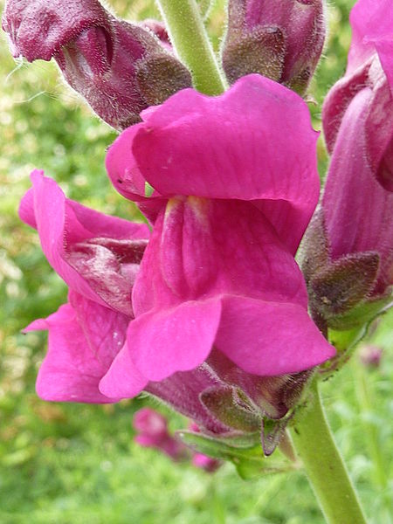

2.1.13. Interactions between gene loci – 1
Introduction | What is epistasis?
Introduction | In what two ways can epistasis work? | 1. | 2.
Working antagonistically | Alleles which are prevented from being expressed by a homozygous recessive allele at a different locus are called what?
Working antagonistically | In recessive epistasis, what is the most common ratio?
Working antagonistically | In recessive epistasis, what must be expressed in the genotype for the hypostatic alleles to be expressed in the phenotype?
Working antagonistically | What are the typical ratios in dominant epistasis? | 1. | 2.
Working in a complementary fashion | Using the example on p. 129 (sweet peas), what must be present for flowers to be purple?
Working in a complementary fashion | What is the typical ratio for epistasis by complementary action?

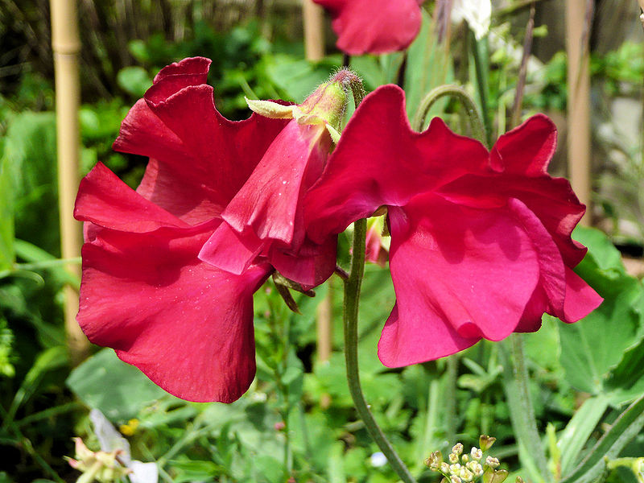

2.1.15. Interactions between gene loci – 2
Explain why coat colour in mice could be described as a two-stage process?
Complete the table for mice coat colour:
  Genotype | Phenotype
  AABB
  AABb
  AAbb
  AaBB
  AaBb
  Aabb
  aaBB
  aaBb
  aabb

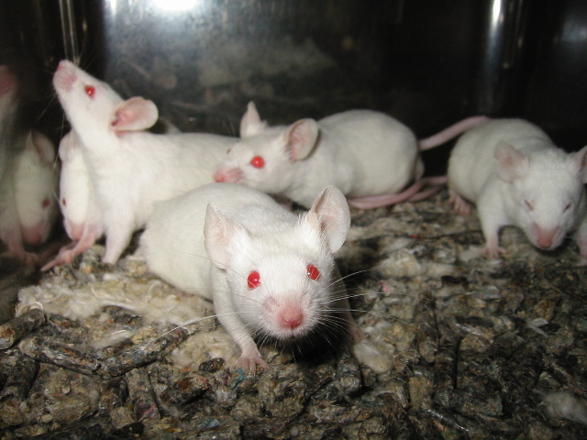

2.1.16 The chi-squared (χ²) test
What is a null hypothesis?
What is the chi-squared test used for?
What type of data is the test used on?
Give three criteria which must be met when using the chi-squared test. | 1. | 2. | 3.
If the value of chi-squared is high, what does this indicate?
What does a p-value of 0.05 mean?
How do you calculate degrees of freedom?

Quick Quiz 3 – Sections 2.1.10 to 2.1.16

?
1. Match the terms to their definitions.

1. Heterozygous |  | Alleles that both contribute to the phenotype
2. Dominant |  | Where one gene masks or suppresses the expression of another
3. Codominant |  | Two or more genes located on the same chromosome
4. Epistasis |  | Two different alleles of the same gene
5. Null hypothesis |  | Always expressed in the phenotype
6. Linkage |  | Assumption that there is no significant difference between observed and expected values

2. Complete the table of genetic ratios and scenarios.

Ratio | Scenario
9:3:3:1
 | Recessive epistasis
12:3:1 or 13:3
 | Epistasis by complementary action

Please continue overleaf
3. Tomato plants can have red or yellow tomatoes and smooth or spiky leaves. The alleles are as follows:

R – allele for red tomatoes L – allele for smooth leaves
r – allele for yellow tomatoes l – allele for spiky leaves

A homozygous red tomato producing, smooth-leaved plant was crossed with a homozygous yellow tomato producing, spiky-leaved plant.

a) What is the genotype and phenotype of the F₁ offspring?

b) These offspring were allowed to self-pollinate. Using a genetic diagram show the expected ratios of each of the different phenotypes.

c) 400 offspring were produced with the following numbers: 230 red tomato producing, smooth-leaved; 72 red tomato producing, spiky-leaved; 78 yellow tomato producing, smooth-leaved; and 20 yellow tomato producing, spiky-leaved plants.

Use the chi-squared test to calculate whether the observed results fit standard Mendelian genetics. Remember to start with a null hypothesis. Use the χ² table in your textbook on p. 135.

Null hypothesis: any difference between the observed and expected values is by chance and is not significant

Class | Observed (O) | Expected (E) | O-E | (O-E)2 | (O-E)2/E

2.1.17 Continuous and discontinuous variation
Introduction | What was Darwin’s theory of variation among organisms? Was it continuous or discontinuous?
Introduction | What discovery backed up Mendel’s discontinuous theory?
Discontinuous variation | What is discontinuous variation? Give an example.
Continuous variation | What is continuous variation? Give an example.
The genetic basis of discontinuous and continuous variation | In discontinuous variation, when more than one gene is involved, how do they react?
The genetic basis of discontinuous and continuous variation | What is the minimum number of genes involved in continuous variation?
The genetic basis of discontinuous and continuous variation | What are polygenes?
Genotype and environment contribute to the phenotype | Can the environment have an effect on phenotype?
Genotype and environment contribute to the phenotype | What is influenced more by the environment, polygenic (continuous) or monogenic (discontinuous) genes?
Variation and selection | What is essential in selection?
Variation and selection | In natural selection how does selection occur?
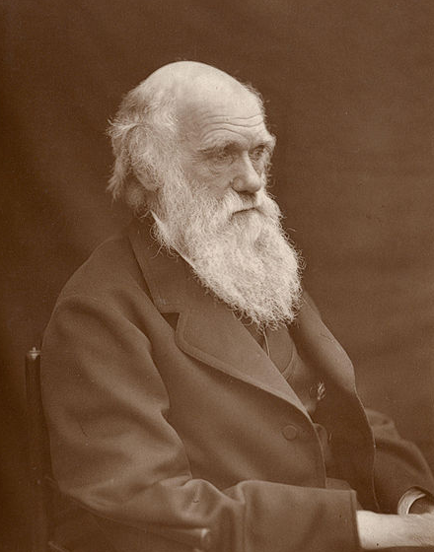
2.1.18 Population genetics
Introduction | What equation can be used to measure the pool of genetic diversity of a group?
Introduction | What three things did Darwin deduce about population genetics? | 1. |  |  | 2. |  | 3.
The birth of population genetics | What is a population?
The birth of population genetics | What is a gene pool?
Measurement of allele and genotype frequencies | When can the frequency of alleles in the population be directly measured?
Measurement of allele and genotype frequencies | Why can’t the frequency of alleles be calculated directly for traits that have a recessive allele?
Measurement of allele and genotype frequencies | Eye colour in pandas is controlled by two alleles: E^{B} and E^{G}.  Pandas can have:  • Brown eyes (genotype E^{B} E^{B})  • Green eyes (genotype E^{G} E^{G})  • Blue eyes (genotype E^{B} E^{G}) | In a population of 150 pandas, 32 have brown eyes and 62 have green eyes. Calculate the frequency of E^{B} and E^{G} alleles.
The Hardy–Weinberg principle | What four assumptions does the Hardy–Weinberg principle rely on? | 1. | 2. |  |  | 3. |  | 4.
The Hardy–Weinberg principle | What part of the Hardy–Weinberg equation represents the heterozygous carriers?
The Hardy–Weinberg principle | A new genetic disease is discovered. Individuals affected with the disease are homozygous recessive (ndnd) for the allele involved. Heterozygotes (NDnd) individuals show no symptoms and are carriers, and homozygous dominant (NDND) individuals are healthy. | In a population study, 4,000 people were tested and three were found to be affected by the disease. Calculate the number of carriers to the nearest whole person in the population.

2.1.19 The roles of genes and environment in evolution
Environmental factors can act as stabilising or evolutionary forces of natural selection | What is carrying capacity?
 | What do environmental factors that limit the growth of a population provide?
 | What is selection pressure?
 | Suggest an environmental change that might cause a directional selection in Shetland ponies that could have long or short hair.
 | What is the difference between stabilising and directional selection?
 | What are the three isolating mechanisms? Give an example of each. | Isolating mechanism | Example
 |  | 1.
 |  | 2.
 |  | 3.
 | At what point do sub-populations become different species?
How does genetic drift lead to large changes in small populations? | What is genetic drift?
 | What may genetic drift lead to?
 | Why can genetic drift lead to such big changes?
 | How can isolating mechanisms lead to new species?
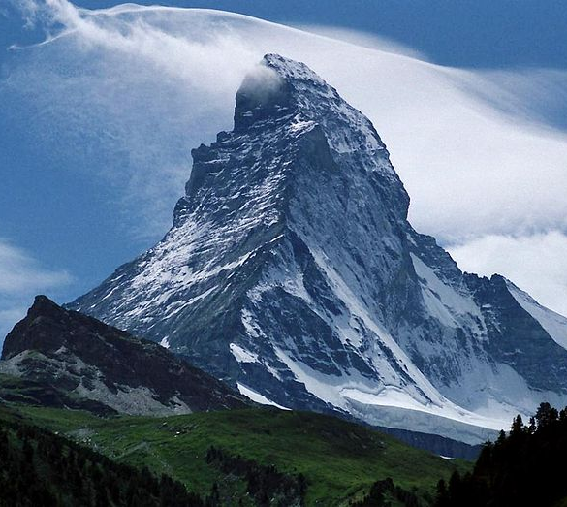
2.1.20 What is a species?
What is the biological species concept?
Give one problem with the biological concept model.
What is the phylogenetic species concept?
Match the term to the correct definition.
  1. Clade |  | Particular base pair sequences
  2. Monophyletic |  | Group of organisms with haplotypes more similar to each other than any other group
  3. % divergence |  | Taxonomic group with a single ancestral organism and all its descendants
  4. Haplotype |  | Differences in base pair sequences caused by mutations
Does cladistics have fixed levels of classification as in the Linnaean system?
What is a paraphyletic group?

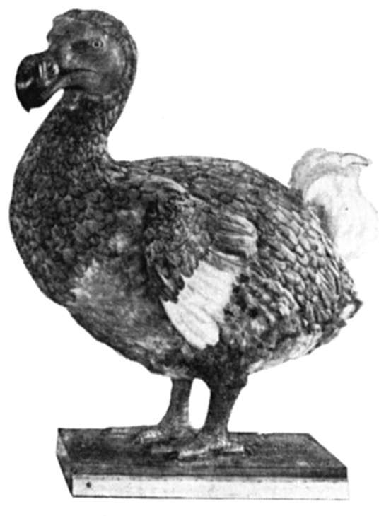

2.1.21 Natural and artificial selection
What is natural selection?
Give a brief description of artificial selection.
Give two ways in which farmers can increase the number of offspring of elite cows and bulls to improve their milk yield. | 1. | 2.
How do farmers make cows produce many eggs?
After the eggs are fertilised in vitro, what happens to the embryos?
Give the six stages breeders use to produce high milk yielding daughters. | 1.
 | 2.
 | 3.
 | 4.
 | 5.
 | 6.
What does polyploidy mean?
How many chromosomes are in the nucleus of most wild species of wheat?
How many chromosomes are in the nucleus of modern bread wheat?
Why is it desirable to have wheat nuclei with higher numbers of chromosomes?
What is the genotype of modern domesticated wheat and where does each component come from?
In the modern species of domesticated wheat, how many genomes are included in the hybrid?
What characteristics are focused on when using artificial selection to improve wheat?
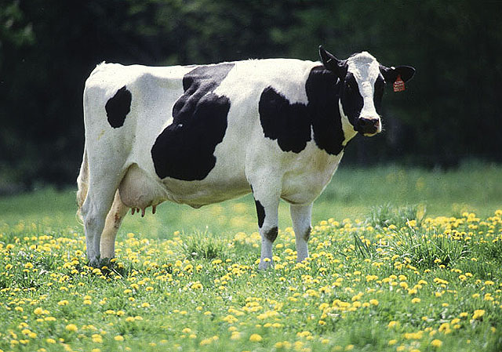
Quick Quiz 4 – Sections 2.1.17 to 2.1.21
?

1. Match the terms to their definitions.

1. Discontinuous  variation |  | A process in which humans can select organisms with useful characteristics
2. Continuous variation |  | Has no distinct categories and a wide range of variation
3. Population |  | A group including an ancestral organism and all its descendent species
4. Stabilising selection |  | A group of individuals of the same species that can interbreed
5. Monophyletic group |  | Has clearly distinguishable characteristics between categories
6. Artificial selection |  | When natural selection keeps things the way they are

2. Use the following table to compare continuous and discontinuous variation.

Discontinuous variation | Continuous variation

3. Fill in the gaps.

The environment has some effect on population; some _____________________ __________ act to limit the growth of a population, these include __________, __________ and the presence of pathogens and are said to provide __________ __________. Selection pressure is an environmental factor which __________ the chances of a particular phenotype being passed on to the next generation. Populations can be separated into sub-groups by __________________ __________; these can be geographic or seasonal. When sub-populations can no longer breed together a new __________ is created.

