Module 4 – Responding to the environment
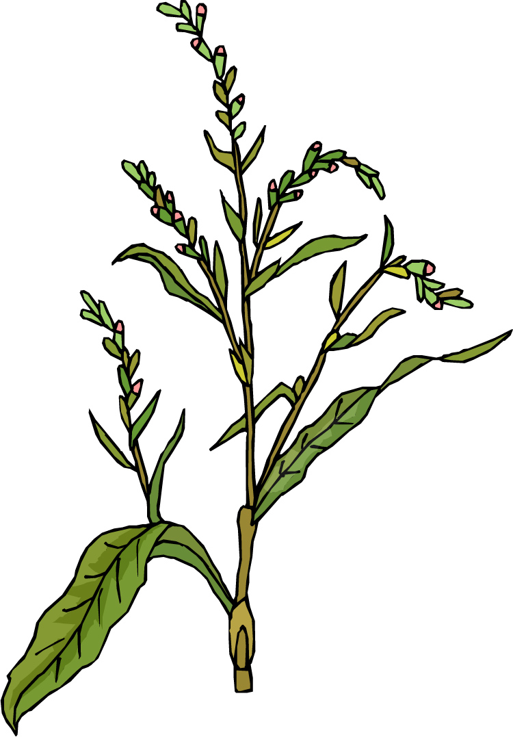
2.4.1 Why plants respond to the environment
Plants respond to stimuli | What is tropism?
Plants respond to stimuli | How might tropism help a plant?
Plants respond to stimuli | Name and briefly describe four tropisms. | 1.
Plants respond to stimuli | Name and briefly describe four tropisms. | 2.
Plants respond to stimuli | Name and briefly describe four tropisms. | 3.
Plants respond to stimuli | Name and briefly describe four tropisms. | 4.
What controls plant responses? | What is the difference between ‘-trophic’ and ‘-tropic’?
What controls plant responses? | What type of chemical is involved in tropic responses?
What controls plant responses? | What is a plant hormone?
What controls plant responses? | What is the difference between animal and plant hormones?
What controls plant responses? | How do hormones target the correct cells in a plant?
What controls plant responses? | How can hormones move around the plant? | 1. | 2. | 3.
What controls plant responses? | Match the hormone to its effect
  1. Auxins | Causes stomatal closure when stressed
  2. Cytokinins | Promote seed germination and stem growth
  3. Gibberellins | Promote cell elongation
  4. Abscisic acid | Promotes fruit ripening
  5. Ethene | Promote cell division
2.4.2 How plants respond to the environment
Plant growth | What limits a plant cell’s ability to divide?
Plant growth | What are the areas of plants, which can divide, called?
Plant growth | Complete the table about plant meristems:
  Type | Function
  Apical meristems
   | Found in buds, could give rise to side shoots
   | Found near the outside of roots and shoots, responsible for widening
  Intercalary meristems
Plant growth | Where does cell division happen in a shoot?
Plant growth | What happens just behind the apex?
Plant growth | How do auxins travel?
Plant growth | What determines the amount of cell elongation?
Plant growth | What do auxins promote to increase the stretchiness of cell walls?
Plant growth | What does this process activate?
Plant growth | What do these molecules do?
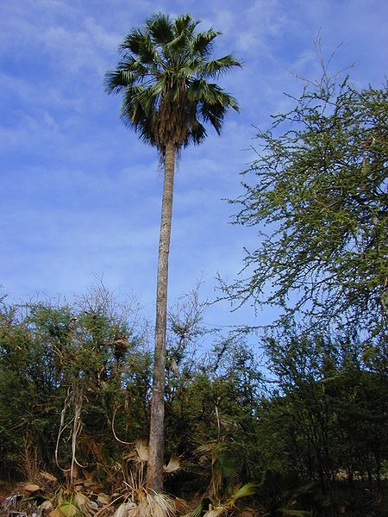

What causes phototropisms? | Which way will a shoot bend when a light source is placed on it?
What causes phototropisms? | How does this occur?
What causes phototropisms? | What happens to auxins during phototropism?
What causes phototropisms? | What enzymes are thought to be involved in the redistribution of auxins?
What causes phototropisms? | What colour of light corresponds to 400–450nm?
What causes phototropisms? | Where is there least activity of phototropin 1?
Shedding leaves | What is the scientific term for ageing of leaves?
Shedding leaves | What does phloem transport provide leaves with?
Shedding leaves | What are the effects of cytokinins on leaves of deciduous trees?
Shedding leaves | What is abscission?
Complete the flow diagram explaining leaf senescence: | Leaves senescence reduces auxin production at the leaf tip  This causes  Petiole separates from the stem

2.4.3 Controlling plant growth
Apical dominance | What is apical dominance?
Apical dominance | What happens when the tip of a shoot is removed? Why?
Apical dominance | What is an alternate explanation for the results of apical dominance experiments?
Apical dominance | How did Ken Thimann and Folke Skoog disprove these alternative theories?
Apical dominance | Even after the auxin transport experiments why is there a possibility that there is not a simple relationship between auxin concentration and growth inhibition?
Apical dominance | What was Gocal’s theory that disproved a direct causal link between auxin concentration and growth inhibition?
Apical dominance | What two other hormones are now thought to be involved in lateral bud growth? | 1. | 2.
Gibberellins and stem elongation | Which hormones are involved in the plant disease bakanae?
Gibberellins and stem elongation | What is the effect of this disease?
Gibberellins and stem elongation | Why can we not immediately say that gibberellins are responsible for stem growth in nature?
Gibberellins and stem elongation | How did scientists investigate gibberellins at natural concentrations?
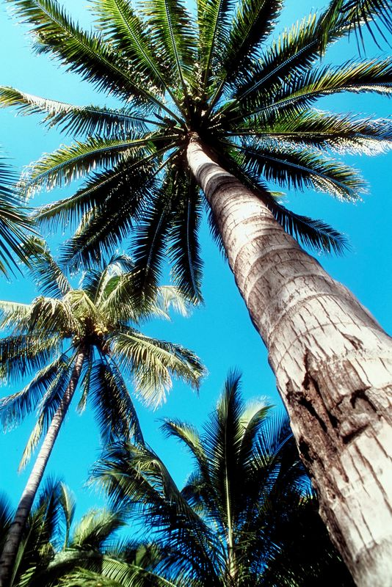
2.4.4 Commercial uses of plant hormones
Auxins | What effect can auxins have in high concentrations?
Auxins | Why is this an economic advantage?
Auxins | What effect does auxin have in parthencarpy?
Gibberellins | Give two ways in which gibberellins can be used to improve fruit shape. | 1.
Gibberellins |  | 2.
Gibberellins | What role do gibberellins play in brewing?
Gibberellins | What effect do gibberellins have on sugar cane?
Gibberellins | What is a commercial benefit of inhibiting gibberellins?
Cytokinins | How can cytokinins be of use to supermarkets?
Ethene | Why is 2-chloroethylphosphonic acid used instead of ethene?
Ethene | Give four commercial uses of ethane. | 1.
Ethene | Give four commercial uses of ethane. | 2.
Ethene | Give four commercial uses of ethane. | 3.
Ethene | Give four commercial uses of ethane. | 4.
Ethene | How can ethene production be reduced?
Ethene | What commercial benefit can inhibiting ethene production have?
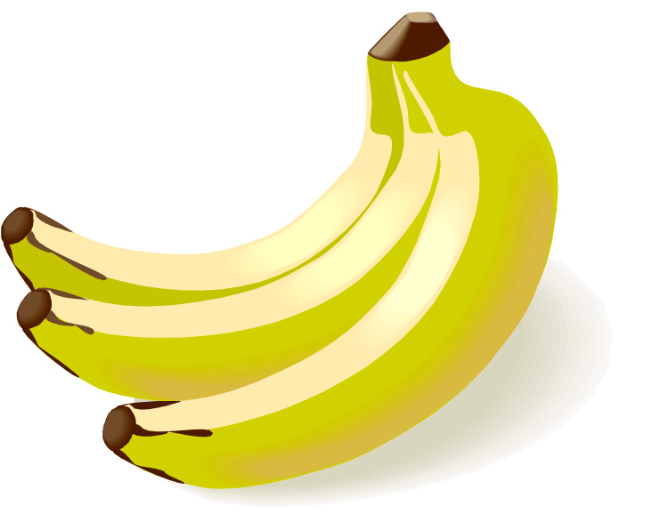

Quick Quiz 1 – Sections 2.4.1 to 2.4.4
?

1. Match the terms to the correct definitions.

1. Phototropism |  | Areas of the plant where cells can divide
2. Hormone |  | Wall loosening enzyme
3. Meristems |  | Ageing of leaves
4. Expansins |  | Chemical is involved in tropic responses
5. Senescence |  | Speed up the ripening of some fruit
6. Ethene |  | Growth towards light

2. Draw a diagram to demonstrate phototropism.

2.4.5 The brain
The structure of the human brain | What is the largest part of the brain?
The structure of the human brain | What connects the two hemispheres of the brain?
The structure of the human brain | What is the cerebral cortex?
The structure of the human brain | What three types of areas are found in the cerebral cortex? | 1. | 2. |  | 3.
The structure of the human brain | Which side of the brain controls the right foot?
The structure of the human brain | What part of the body has the most motor control according to the diagram on p. 228?
The structure of the human brain | What is the role of the cerebellum?
The structure of the human brain | Where do neurones from the cerebellum carry impulses?
The structure of the human brain | Name four parts of the body from which the cerebellum receive sensory information.
The structure of the human brain | What does the hypothalamus control?
The structure of the human brain | What role will the medulla oblongata play during exercise?

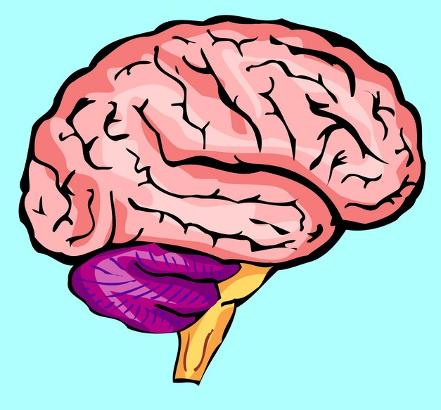

2.4.6 Organising the nervous system
Responding to the environment | Why might a mouse need to respond to its environment?
Subdividing the nervous system | What are the components of the central nervous system?
Subdividing the nervous system | What is grey matter?
Subdividing the nervous system | What makes the white matter appear white?
Subdividing the nervous system | What is the role of the peripheral nervous system?
Subdividing the nervous system | In which direction do motor fibres run?
Subdividing the nervous system | Name the two subdivisions of the motor system. | 1. | 2.
Subdividing the nervous system | Which of the divisions of the motor system are involved with voluntary movements?
The autonomic nervous system | Give three differences between the autonomic and the somatic nervous systems. | 1.
The autonomic nervous system |  | 2.
The autonomic nervous system |  | 3.
The autonomic nervous system | Why are the two subsystems of the autonomic nervous system referred to as antagonistic?
The autonomic nervous system | What happens under normal resting conditions to both the sympathetic and parasympathetic systems?
The autonomic nervous system | What is the neurotransmitter, which acts at the synapse between neurones and effector of parasympathetic neurons?
The autonomic nervous system | What autonomic system will be most active if you were being chased by a bull? What would its effect be on your heart rate?

2.4.7 Coordinated movement
Action of muscles | When do muscles produce force?
Action of muscles | What is an antagonistic pair?
Action of muscles | What are groups of muscles called which produce more complex movements?
Action of muscles | What type of joint is the elbow?
Action of muscles | Draw a diagram of a synovial joint and label the main features.
Action of muscles | What role does the synovial fluid play in a joint?
Action of muscles | Which two muscles act as antagonists at the elbow? | 1. | 2.
Action of muscles | What part of the body do these muscles move?

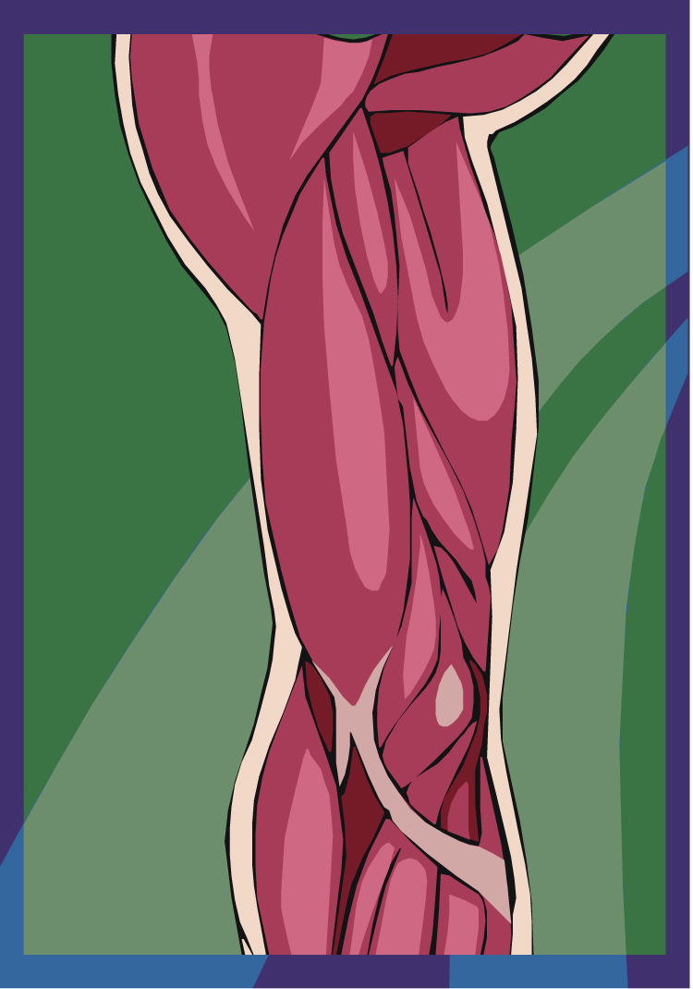

Control of contraction | Where are motor neurons connected to muscle cells?
Control of contraction | What neurotransmitter is released at the neuromuscular junction?
Control of contraction | What controls the strength of muscle contractions?
Control of contraction | What is a motor unit?
Control of contraction | Describe a graded response.
Control of contraction | What response is elicited by a single electrical stimulus to a muscle?
Control of contraction | What happens if you gradually increase the size of the single electrical stimulus?
Control of contraction | What is summation?
Control of contraction | What is tetanus?
Control of contraction | How is tetanus produced?

2.4.8 Three types of muscle
Muscle structure | What two proteins are highly abundant in all muscles? | 1. |  | 2.
Muscle structure | Name the three types of muscle. | 1. | 2. |  | 3.
Involuntary (smooth muscle) | What innervates smooth muscle?
Involuntary (smooth muscle) | Match the smooth muscle locations to the action they produce when they contract
  1. Walls of intestine | Reduces blood flow
  2. Walls of arteries | Dilates the pupil
  3. Iris of eye | Peristalsis
Involuntary (smooth muscle) | What shape are smooth muscle cells?

Cardiac muscle | Give the three types of cardiac muscle. | 1.
Cardiac muscle | Give the three types of cardiac muscle. | 2.
Cardiac muscle | Give the three types of cardiac muscle. | 3.
Cardiac muscle | What is the main difference between atrial and ventricular contraction compared to skeletal muscle contraction?
Cardiac muscle | What is the role of the specialised excitatory fibres?
Cardiac muscle | What does myogenic mean?
Cardiac muscle | What effect does parasympathetic stimulation have on the heart?
Cardiac muscle | Where is the highest proportion of specialised excitatory fibres?
Cardiac muscle | How do electrical impulses spread between the atria and the ventricles?
Cardiac muscle | What are Purkyne fibres?
Cardiac muscle | What feature of intercalated discs allows action potentials to pass easily between cardiac muscle fibres?
Voluntary (skeletal or striated) muscle | Approximately how wide are muscle fibres?
Voluntary (skeletal or striated) muscle | What is the sarcoplasm?
Voluntary (skeletal or striated) muscle | What organelle is upregulated in muscle cells?
Voluntary (skeletal or striated) muscle | What are myofibrils? What are they composed of?
Voluntary (skeletal or striated) muscle | What are the main characteristics of skeletal muscle?
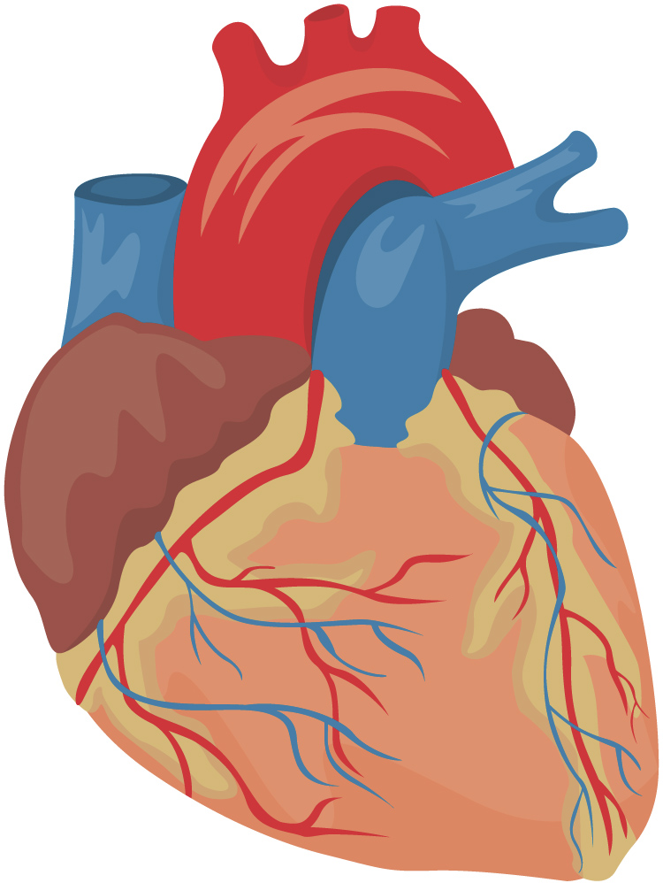
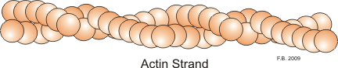

2.4.9 The sliding filament theory
The sarcomere | What is the name for the area from Z-line to Z-line?
The sarcomere | What happens to the I-band and H-zone during contraction?
The sarcomere | Which band stays the same length during contraction?
The sarcomere | Draw a simple diagram of a sarcomere labelling the main features.

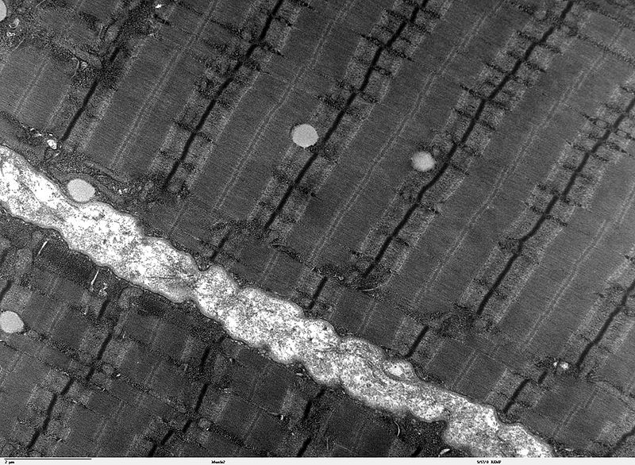

Two types of protein filament are involved in contraction | What is the name of the thin filament in muscles?
Two types of protein filament are involved in contraction | What is the basic structure of this filament?
Two types of protein filament are involved in contraction | What is coiled around the filamentous actin?
Two types of protein filament are involved in contraction | Where is troponin attached to the thin filament?
Two types of protein filament are involved in contraction | What protein makes up the thick filament?
Two types of protein filament are involved in contraction | What is a cross-bridge?
Two types of protein filament are involved in contraction | What is released during the power stroke?
Two types of protein filament are involved in contraction | What causes the cross-bridge to be broken?
Two types of protein filament are involved in contraction | What happens to the myosin head as the ATP is hydrolysed?
Two types of protein filament are involved in contraction | True or false? | Only the sarcomere shortens during contraction
Two types of protein filament are involved in contraction | True or false? | The sarcomere and the muscle length shorten during contraction
Two types of protein filament are involved in contraction | True or false? | Neither the sarcomere or muscle length shorten during contraction
Two types of protein filament are involved in contraction | What blocks the myosin from binding to the actin?
Two types of protein filament are involved in contraction | What do the calcium ions bind to in the sarcoplasm?
Two types of protein filament are involved in contraction | What effect does this binding have on troponin and tropomyosin?
Two types of protein filament are involved in contraction | What happens to calcium ions when the nervous stimulation to muscle cells stops?
Two types of protein filament are involved in contraction | What does the energy from ATP hydrolysis do?
Maintenance of ATP supply | What three mechanisms maintain the level of ATP high enough to allow continued contraction? | 1.
Maintenance of ATP supply |  | 2.
Maintenance of ATP supply |  | 3.

2.4.10 Pulling together – muscles, nerves and hormones
Responding to environmental stimuli | What controls mammals’ responses to environmental stimuli?
The ‘fight or flight’ response | What three things happen to blood during the fight or flight response? | 1.
The ‘fight or flight’ response |  | 2.
The ‘fight or flight’ response |  | 3.
The ‘fight or flight’ response | What three effects does the hypothalamus elicit during a fight or flight response? | 1.
The ‘fight or flight’ response |  | 2.
The ‘fight or flight’ response |  | 3.
The ‘fight or flight’ response | What is a stressor?
The ‘fight or flight’ response | What stimulates the release of hormones, which help the body to resist stressors?
The ‘fight or flight’ response | What do some animals do instead of fighting or fleeing?

Quick Quiz 2 – Sections 2.4.5 to 2.4.10
?

1. Match the terms to the correct definitions.

1. Corpus collosum |  | Two muscles which work against each other to create movement
2. Hypothalamus |  | Connects the two hemispheres of the brain
3. Grey matter |  | Area of non-myelinated neurones
4. Tetanus |  | Controls the autonomic nervous system and the endocrine glands
5. Synovial fluid |  | Acts as a lubricant
6. Antagonistic pair |  | A sustained powerful contraction

2. Complete the table on the autonomic nervous system

 | Parasympathetic | Sympathetic
When active
Neurones and links
Neurotransmitters at effector
Effects of action

3. Draw a diagram showing the events at a neuromuscular junction when an action potential in a neurone leads to a muscle contraction.
2.4.11 Innate behaviour
What is meant by behaviour? | What is behaviour?
What is meant by behaviour? | What two types of response are there? | 1. |  | 2.
Innate and learned behaviours | What is an innate behaviour?
Examples of innate behaviour | What three behaviours are key to invertebrates? | 1. | 2. |  | 3.
Examples of innate behaviour | Define escape reflexes.
Examples of innate behaviour | Define taxes.
Examples of innate behaviour | Define kinesis.
Examples of innate behaviour | What three factors of invertebrates mean that innate behaviours are more suitable for survival than learned ones? | 1.
Examples of innate behaviour |  | 2.
Examples of innate behaviour |  | 3.
Examples of innate behaviour | What is the main function of the invertebrate’s reflex behaviour?
Examples of innate behaviour | Describe how a woodlouse reacts when it is in a light, dry area.
Examples of innate behaviour | What is movement up a chemical gradient called?
Examples of innate behaviour | Give an example of an invertebrate, which uses chemotaxis.
Examples of innate behaviour | What causes female three-spined sticklebacks to release eggs?
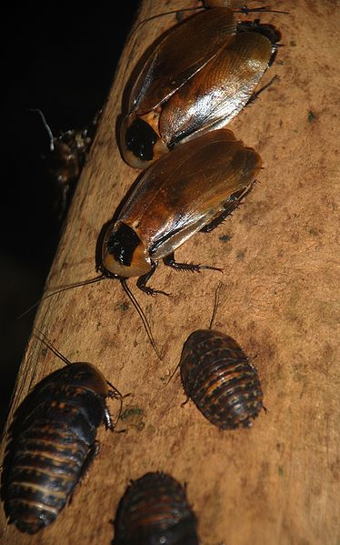

2.4.12 Behaviour can be learned
What is learned behaviour? | What is learned behaviour?
What is learned behaviour? | What is the main advantage of learned behaviour over innate behaviours?
Classifying learned behaviours | Complete the table of learned behaviours:
  Learned behaviour | Description | Example
  Habituation
  Imprinting
  Classical conditioning
  Operant conditioning
  Latent learning
  Insight learning

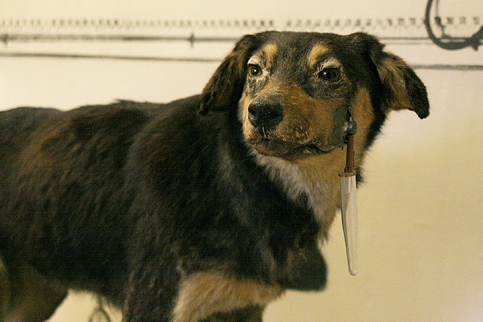

2.4.13 Primate behaviour
Introduction | What is a hierarchy?
Introduction | What is social behaviour?
Social organisation in gorillas | What are the three main social roles of the dominant male gorilla? | 1.
Social organisation in gorillas |  | 2.
Social organisation in gorillas |  | 3.
Social organisation in gorillas | What do young female gorillas do as they mature?
Social behaviours in gorillas | What do gorillas do to each other, which reinforces relationships between individuals?
Social behaviours in gorillas | What are the three uses of communication systems for gorillas? | 1.
Social behaviours in gorillas |  | 2.
Social behaviours in gorillas |  | 3.
The advantages of social behaviour | Give five advantages of social behaviour in primates. | 1.
The advantages of social behaviour | Give five advantages of social behaviour in primates. | 2.
The advantages of social behaviour | Give five advantages of social behaviour in primates. | 3.
The advantages of social behaviour | Give five advantages of social behaviour in primates. | 4.
The advantages of social behaviour | Give five advantages of social behaviour in primates. | 5.
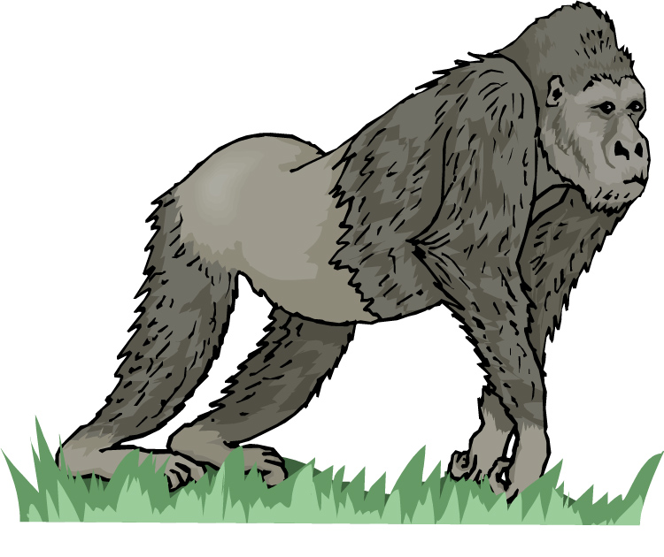

2.4.14 Human behaviour, dopamine and DNA
Structure and activity | What are the three roles of dopamine? | 1. | 2. | 3.
Structure and activity | What disease is caused by abnormally low levels of dopamine?
Structure and activity | What disease has been linked with dopamine levels which are too high?
Structure and activity | How many dopamine receptors are there?
The DRD4 receptor | What is DRD4?
The DRD4 receptor | What differs between variants of DRD4?
The DRD4 receptor | What disorder has been linked with a particular variant of DRD4?
The DRD4 receptor | Other than ADHD what else is the DRD4 receptor thought to be linked with?
The DRD4 receptor | What, other than general arousal, is different in individuals taking L-dopa to individuals taking haloperidol?
Other neurotransmitter-influenced behavioural conditions | What neurotransmitter is thought to be deficient in OCD?
Other neurotransmitter-influenced behavioural conditions | What is psychosis?
Other neurotransmitter-influenced behavioural conditions | Why should the idea of ‘the genes for specific behaviours’ idea be treated with caution?
Other neurotransmitter-influenced behavioural conditions | What else, other than genes, play a role in human behaviour?
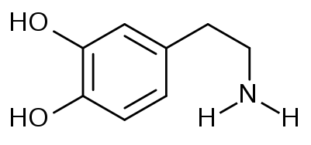
Quick Quiz 3 – Sections 2.4.11 to 2.4.14
?

1. Match the terms to the correct definitions.

1. Behaviour |  | Disease caused by abnormally low levels of dopamine
2. Imprinting |  | Behavioural mechanism key to invertebrates
3. Hierarchy |  | Responses of an organism to its environment which increase its chances of survival
4. Parkinson’s |  | A system in a group of organisms where individuals have a place in the order of importance within the group
5. Psychosis |  | Animals become associated with another organism, usually a parent
6. Reflexes |  | Mental health condition characterised by an impaired grasp on reality, diminished impulse control and disorder of perception

2. Complete the sentences.

a Innate behaviour is any animal response that occurs without

b Kineses are orientation behaviours where the rate of movement

c In habituation, animals learn to ignore certain stimuli because

d Learned behaviour is described as

e Hierarchies lead to social control within the group which

f The range of activities affected by dopamine is partly due to

