1. A balanced diet is essential for good health.
Complete the following passage by using the most appropriate terms from the list to fill the gaps.
Each term should not be used more than once.
haemoglobin iron collagen obese
calcium anorexic sodium
A balanced diet is one which provides an adequate intake of energy and nutrients for
the maintenance of our body. If energy intake exceeds energy usage over a period of
time, an individual can become ……….………………… .
The deficiency disease anaemia can be caused by a lack of the mineral
……….………………… in the diet. As a result of this deficiency, the body is unable to
produce sufficient amounts of the protein ……….………………… in red blood cells.
[Total 3 marks]

2. The Body Mass Index (BMI) is one way of determining whether a person is underweight or overweight.
BMI can be calculated using the formula:
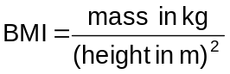
Calculate the BMI of a female of mass 69 kg and a height of 1.67 m.
Show your working. Give your answer to one decimal place.

Answer = ..........................................
[Total 2 marks]

3. A way of determining whether a person is underweight or overweight is to use a graph showing the relationship between height and body mass.
The figure below is an example of this type of graph.
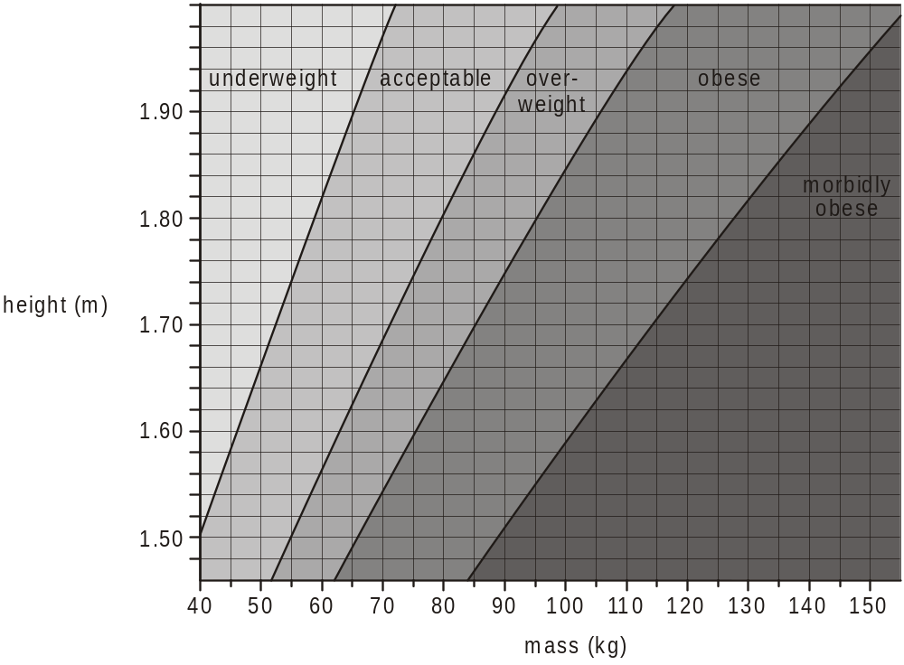

(i) Using the figure above, state the category into which a female who has a body mass of 69 kg and a height of 1.67 m is placed.
.........................................................................................................................
[1]

(ii) There are many factors that determine the category into which a person is placed. The figure above does not take into account all of these factors.
Suggest why the female in (i) might be placed in the wrong category.
.........................................................................................................................
.........................................................................................................................
.........................................................................................................................
.........................................................................................................................
[2]
[Total 3 marks]

4. Name two diseases associated with obesity.
1 ...............................................................................................................................
2 ...............................................................................................................................
[Total 2 marks]

5. Coronary heart disease (CHD) can be described as a multifactorial disease. This means that a number of different risk factors contribute to the development of the disease.
The figure below shows the percentage of cases of CHD in a population to which each risk factor contributed.
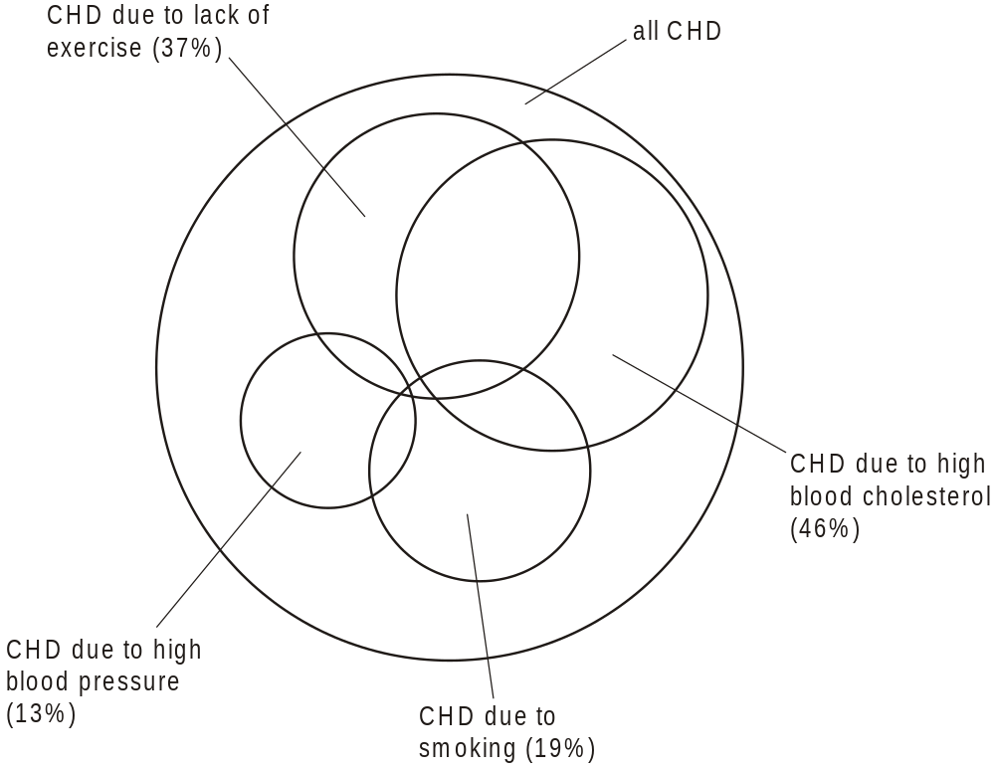

(i) When you add up the different risk factor percentages for the population you find that it is greater than 100%.
Suggest why.
.........................................................................................................................
.........................................................................................................................
[1]

(ii) State two further risk factors that are not shown in the figure above.
1 ......................................................................................................................
2 ......................................................................................................................
[2]

(iii) Smoking is a contributing factor in 19% of all cases of CHD.
The table below lists a number of effects of cigarette smoke.
Use a tick () to indicate which component of cigarette smoke causes each effect.
The first row has been done for you.

effect | nicotine | carbon  monoxide
increases heart rate
constricts arterioles
damages the lining of arteries
reduces the ability of haemoglobin to carry oxygen
makes platelets sticky
[4]
[Total 7 marks]

6. Cholesterol is transported in the form of lipoproteins. High levels of low density lipoproteins (LDLs) in the blood are a risk factor in heart disease.
Outline the role of LDLs in the formation of an atheroma.
..................................................................................................................................
..................................................................................................................................
..................................................................................................................................
..................................................................................................................................
..................................................................................................................................
..................................................................................................................................
[Total 2 marks]

7. An atheroma can grow to a point where it restricts blood flow in a coronary artery, causing coronary heart disease (CHD).
The figure below shows a method of reducing the symptoms of CHD.
A stent is a tubular device, containing a ‘balloon’, which can be inserted into the damaged artery. The stent can be opened up by inflating the balloon.
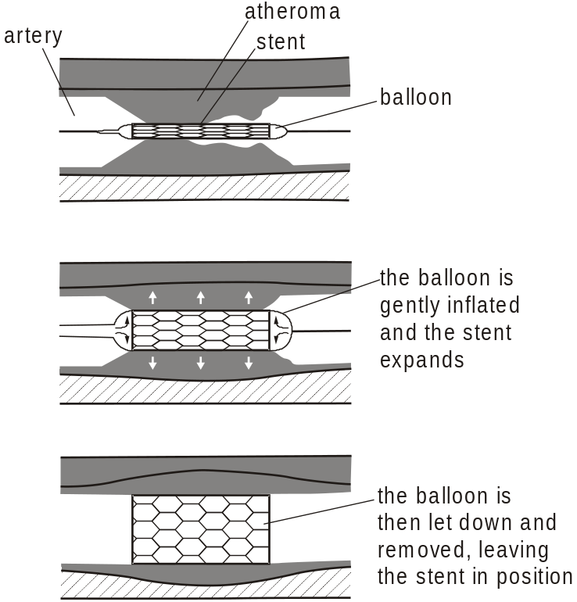

Explain how the inserted stent would reduce the symptoms of CHD.
..................................................................................................................................
..................................................................................................................................
..................................................................................................................................
..................................................................................................................................
..................................................................................................................................
..................................................................................................................................
..................................................................................................................................
..................................................................................................................................
[Total 4 marks]

8. Malaria kills over one million people every year, the vast majority being under the age of ten.
Adults who have survived malaria in childhood and then continue to live in an area where malaria is found, develop a limited form of immunity.
(a) (i) Name the parasite that causes malaria.
................................................................................................................
[1]
(ii) Name the vector for the malarial parasite.
................................................................................................................
[1]
(iii) Name a human cell in which the malarial parasite reproduces.
................................................................................................................
[1]

(b) Scientists are developing a vaccine using an attenuated (inactive) form of the malarial parasite.
The aim is to trigger an immune response without the development of the disease.
Describe the actions of the B lymphocytes in the immune response.
 In your answer you should make clear how the steps in this part of the immune response are sequenced.
.........................................................................................................................
.........................................................................................................................
.........................................................................................................................
.........................................................................................................................
.........................................................................................................................
.........................................................................................................................
.........................................................................................................................
.........................................................................................................................
.........................................................................................................................
.........................................................................................................................
.........................................................................................................................
.........................................................................................................................
[8]

(c) Suggest why adults who have survived malaria may lose their immunity when they leave a malarial area.
.........................................................................................................................
.........................................................................................................................
.........................................................................................................................
.........................................................................................................................
.........................................................................................................................
.........................................................................................................................
[2]

(d) State three biological reasons why it has not been possible to produce an effective vaccine for malaria.
.........................................................................................................................
.........................................................................................................................
.........................................................................................................................
.........................................................................................................................
.........................................................................................................................
.........................................................................................................................
.........................................................................................................................
[3]
[Total 16 marks]

9. The figure below shows a diagram of alveoli in a healthy lung and alveoli in a lung from a person with advanced emphysema.
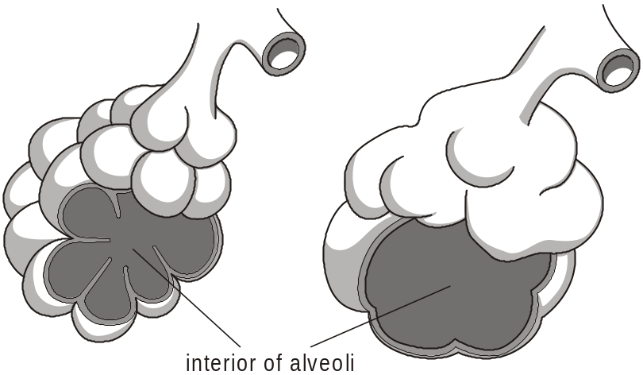
alveoli in a healthy lung alveoli from a person with advanced emphysema

(i) Describe how smoking could cause changes in alveoli, such as those shown in the figure above.
In your answer you should make the links between the changes and their causes clear.
.........................................................................................................................
.........................................................................................................................
.........................................................................................................................
.........................................................................................................................
.........................................................................................................................
.........................................................................................................................
.........................................................................................................................
.........................................................................................................................
.........................................................................................................................
.........................................................................................................................
.........................................................................................................................
.........................................................................................................................
[6]

(ii) Emphysema is a form of chronic obstructive pulmonary disease (COPD).
Describe two signs or symptoms of emphysema.
.........................................................................................................................
.........................................................................................................................
.........................................................................................................................
.........................................................................................................................
.........................................................................................................................
[2]

(iii) Emphysema is described as a chronic disease.
Suggest the meaning of the term chronic.
.........................................................................................................................
.........................................................................................................................
.........................................................................................................................
[2]
[Total 10 marks]

10. An investigation was conducted into the effect of smoking on lung function. One measure of lung function is peak flow rate.
The peak flow rate is the maximum volume of air expelled from the lungs in one minute (dm3 min–1).
Two male volunteers, one a smoker and one a non-smoker, had their peak flow measured once a year for seven years.
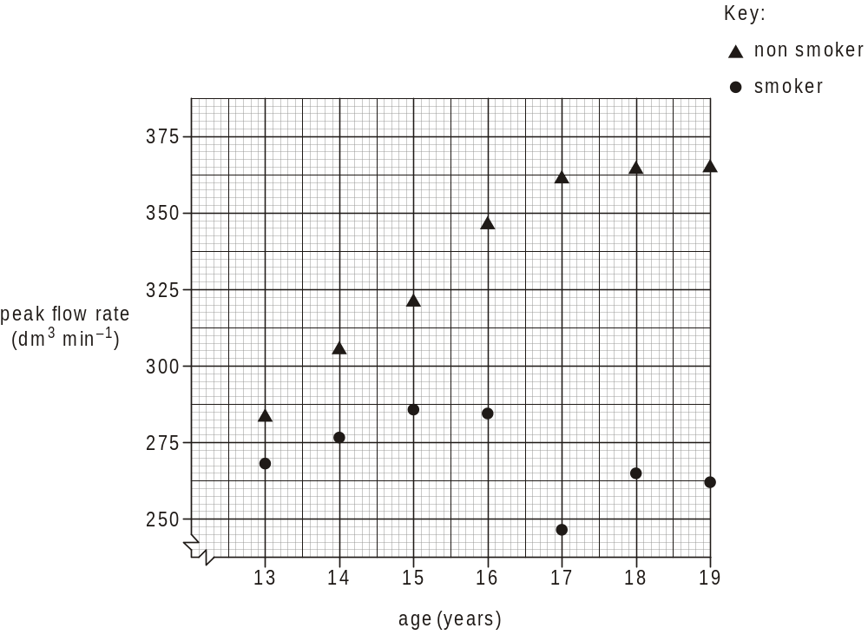

(i) Describe the data shown in the figure above.
.........................................................................................................................
.........................................................................................................................
.........................................................................................................................
.........................................................................................................................
.........................................................................................................................
.........................................................................................................................
.........................................................................................................................
.........................................................................................................................
.........................................................................................................................
[4]

(ii) Explain the results obtained for the smoker.
.........................................................................................................................
.........................................................................................................................
.........................................................................................................................
.........................................................................................................................
.........................................................................................................................
.........................................................................................................................
[2]

(iii) Suggest three ways of improving the reliability of this investigation.
.........................................................................................................................
.........................................................................................................................
.........................................................................................................................
.........................................................................................................................
.........................................................................................................................
.........................................................................................................................
.........................................................................................................................
.........................................................................................................................
.........................................................................................................................
.........................................................................................................................
.........................................................................................................................
.........................................................................................................................
[3]
[Total 9 marks]

11. Acacia senegal is a species of tree which is common in the drier parts of Africa. Cattle are allowed to graze on both its leaves and the fallen seed pods. The seed pods have relatively high protein content.
(i) Describe how you would test an extract of the seed pods for protein.
.........................................................................................................................
.........................................................................................................................
.........................................................................................................................
.........................................................................................................................
.........................................................................................................................
.........................................................................................................................
[2]

(ii) Describe how you could compare the reducing sugar content of the leaves with that of the seed pods.
In your answer you should make clear how the steps in the process are sequenced.
[8]

(iii) The seeds of Acacia species are sometimes eaten by people.
Suggest why it might be better for people living in areas where the tree grows to let their cattle feed on the trees and fallen seed pods and then obtain their nutrition from the cattle.
.........................................................................................................................
.........................................................................................................................
.........................................................................................................................
.........................................................................................................................
.........................................................................................................................
.........................................................................................................................
.........................................................................................................................
.........................................................................................................................
.........................................................................................................................
[3]
[Total 13 marks]

12. An antibody is an example of a protein molecule, which has a specific 3-dimensional shape.
The diagram below shows the structure of an antibody molecule.
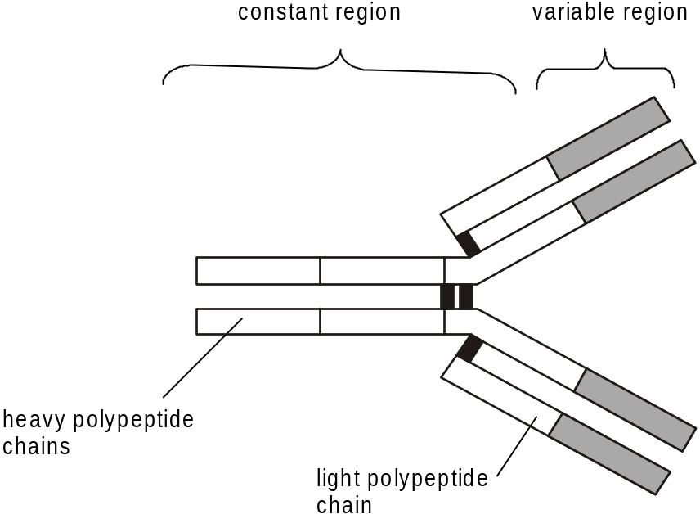

(i) Outline how the structure of an antibody molecule is related to its function.
.........................................................................................................................
.........................................................................................................................
.........................................................................................................................
.........................................................................................................................
.........................................................................................................................
.........................................................................................................................
.........................................................................................................................
[3]

(ii) Suggest why the base sequence in the genes for human antibodies is more similar to that found in a chimp than to that found in a mouse.
.........................................................................................................................
.........................................................................................................................
.........................................................................................................................
[2]
[Total 5 marks]

13. The Human Immunodeficiency Virus (HIV) is spread by exchange of body fluids between an infected person and an uninfected person. This often occurs as a result of unprotected sexual intercourse.
The diagram below shows the percentage of people infected with HIV in different parts of the world at the end of 2002.
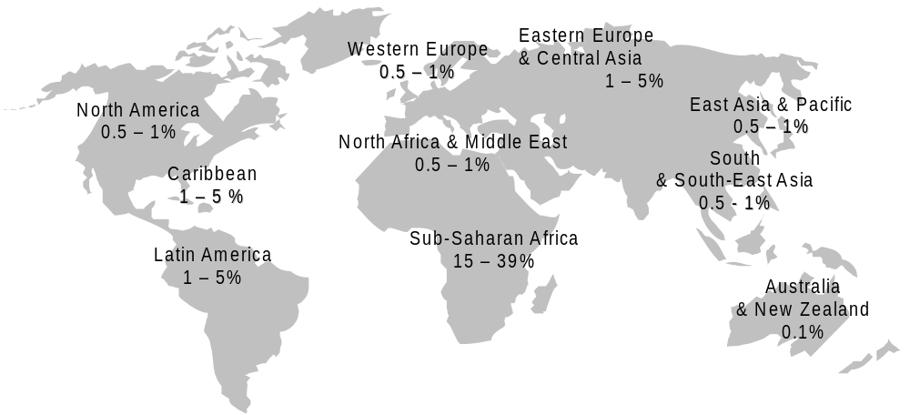
(i) The percentage of people infected with HIV is much higher in Sub-Saharan Africa than in much of Europe.
Suggest three reasons why the percentages are so much higher in Sub-Saharan Africa.
.........................................................................................................................
.........................................................................................................................
.........................................................................................................................
.........................................................................................................................
.........................................................................................................................
.........................................................................................................................
.........................................................................................................................
[3]

(ii) Explain why it is useful to collect information, such as that shown in the figure above.
.........................................................................................................................
.........................................................................................................................
.........................................................................................................................
.........................................................................................................................
.........................................................................................................................
.........................................................................................................................
.........................................................................................................................
.........................................................................................................................
[4]
[Total 7 marks]

14. At present there is no cure for HIV / AIDS. Researchers have found that some people in Africa are not infected despite continual exposure to the disease. HIV uses a specific cell surface receptor known as the CD4 receptor to enter a human cell.
Suggest how this information and knowledge of the Human Genome might be used to help reduce the spread of HIV.
..................................................................................................................................
..................................................................................................................................
..................................................................................................................................
..................................................................................................................................
..................................................................................................................................
..................................................................................................................................
[Total 2 marks]

15. Over the last few years there has been much public concern over the diet of people in the UK and its effects upon their weight and health.
Body Mass Index is a calculation used by doctors to indicate whether a person is underweight or overweight.
(a) State the medical term used to describe a person whose Body Mass Index is greater than 30.
.........................................................................................................................
[1]

The table below shows the daily intake of certain components in three diets,
A, B and C for men in the UK.
Diet A • a normal balanced diet for a typical man
Diet B • a weight-reducing low fat diet
• restricted to avoid fats
• includes any fruit, vegetables and proteins
• energy intake is monitored carefully
Diet C • a weight-reducing low carbohydrate diet
• restricted to avoid carbohydrates
• excludes fruit as these contain sugars
• includes any non-starchy vegetables, proteins and fats
• energy intake is not counted and may exceed 10 000 kJ
on some days
 | Diet A  normal balanced  diet | Diet B  weight-reducing  low fat diet | Diet C  weight-reducing  low carbohydrate  diet
energy / kJ | 9720 | 6000 | 8000
fats / g | 87 | 34 | 124
carbohydrates / g | 275 | 200 | 20
proteins / g | 88 | 76 | 165
combined  minerals / g | 12 | 12 | 18

(b) In any unbalanced diet it is possible that there may be a deficiency of certain nutrients.
Suggest one nutrient that may be deficient in diet B and one in diet C.
Diet B ..............................................................................................................
Diet C ..............................................................................................................
[2]

(c) (i) Explain which diet, B or C, is likely to cause more rapid weight loss.
................................................................................................................
................................................................................................................
................................................................................................................
................................................................................................................
[2]

(ii) State the relationship between energy intake and energy use that would allow a person to lose weight.
................................................................................................................
[1]

(d) Doctors suggested that diet C may not be very healthy in the long term, as it contains unlimited amounts of fats and no fruit.
Suggest what potential health problems, other than continued weight loss, might result in a person who kept to a low carbohydrate diet, similar to diet C.
.........................................................................................................................
.........................................................................................................................
.........................................................................................................................
.........................................................................................................................
.........................................................................................................................
.........................................................................................................................
[3]
[Total 9 marks]

16. Read the following passage and complete each sentence by writing the most appropriate word in the spaces provided.
Health can be defined as a state of complete ....................................., mental and social
well-being. It is not merely the absence of infirmity or ..................................... . Many people
may consider themselves healthy, even though they do not fully match the above criteria. A
young woman can improve her health in a number of ways.
To improve physical well-being she should eat a balanced diet in which the majority of her
energy needs come from ...................................... Her diet should include only small
quantities of ..................................... fats and more plant oils, such as olive oil. She should
exercise for at least ..................................... minutes on three or more occasions per week.
This exercise should be at an intensity that raises her heart rate to .....................................
percent of her maximum heart rate. She should not smoke at all and should avoid passive
smoking.
[Total 6 marks]

17. The diagram below shows the incidence of coronary events and mortality from coronary heart disease (CHD) in some countries around the world. The incidence of coronary events refers to the number of reported cases of any form of coronary illness per 100 000 of the population.
The diagram also shows the prevalence of smoking in the same countries. The prevalence of smoking is the percentage who smoke cigarettes every day.
The figures in the diagram refer to men aged from 35 to 64 during the late 1990s.
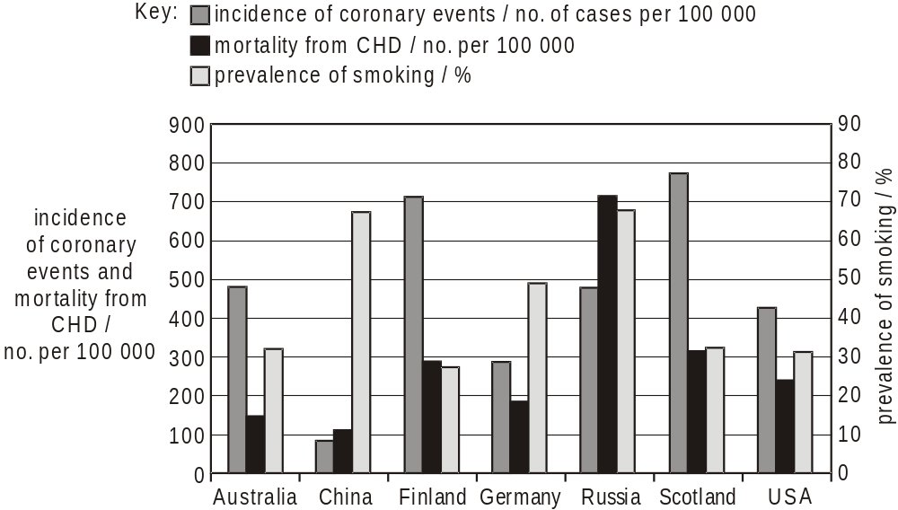
Source: British Heart Foundation Health Promotion Research Group www.heartstats.org

(a) The diagram above shows that the relationship between the incidence of coronary events and the mortality from CHD is not the same in all the countries shown.
Suggest three reasons why this relationship is not the same.
1 ......................................................................................................................
.........................................................................................................................
2 ......................................................................................................................
.........................................................................................................................
3 ......................................................................................................................
.........................................................................................................................
[3]

(b) Using the information in the diagram, describe the evidence to suggest that smoking is not the only factor involved in causing heart disease.
.........................................................................................................................
.........................................................................................................................
.........................................................................................................................
.........................................................................................................................
[2]

(c) Describe three steps a government might take to try to reduce the mortality from CHD.
1 ......................................................................................................................
.........................................................................................................................
2 ......................................................................................................................
.........................................................................................................................
3 ......................................................................................................................
.........................................................................................................................
[3]
[Total 8 marks]

18. Below is a diagram showing the structure of a typical antibody.
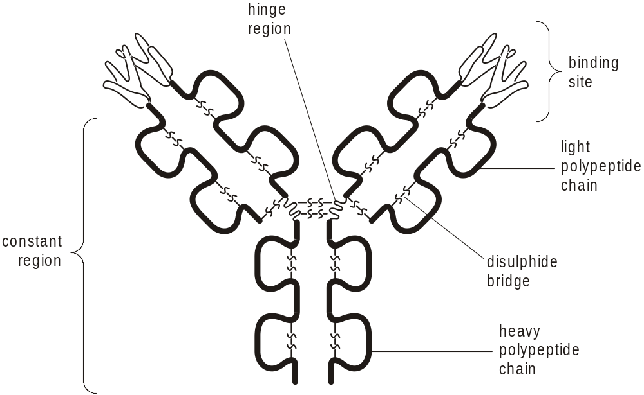

(a) Name the type of cell that produces antibodies.
.........................................................................................................................
[1]

(b) (i) State one function for each of the component parts listed below.
binding site .............................................................................................
................................................................................................................
disulphide bridge ....................................................................................
................................................................................................................
constant region ......................................................................................
................................................................................................................
hinge region ...........................................................................................
................................................................................................................
[4]

(ii) Explain why the part of the antibody molecule incorporating the binding site is often called the variable region.
................................................................................................................
................................................................................................................
................................................................................................................
................................................................................................................
[2]
[Total 7 marks]

19. The figure below shows the concentration of antibodies in the blood following a first infection by a pathogen on day 0.
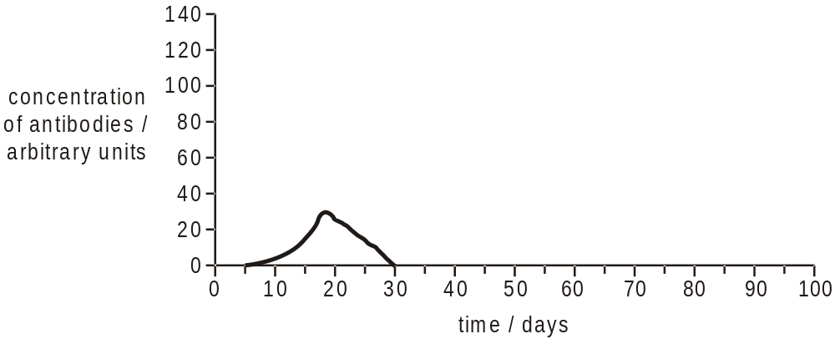

(i) Explain why there is a delay between the first infection by the pathogen and the appearance of antibodies in the blood.
.........................................................................................................................
.........................................................................................................................
.........................................................................................................................
.........................................................................................................................
[2]
(ii) On the figure above, draw a curve to show the expected concentration of antibodies in the blood following a second infection of the same pathogen at day 30.
[2]
[Total 4 marks]

20. Malaria is caused by the parasite Plasmodium which is a single-celled protoctist. At one stage in the life cycle the parasites reproduce asexually within human red blood cells.
(i) Describe how Plasmodium reproduces asexually.
.........................................................................................................................
.........................................................................................................................
.........................................................................................................................
.........................................................................................................................
[2]

(ii) State two advantages of asexual reproduction to a parasite such as Plasmodium.
1 ......................................................................................................................
.........................................................................................................................
2 ......................................................................................................................
.........................................................................................................................
[2]
[Total 4 marks]

21. The table below shows data from research investigating the presence of pesticide (insecticide and herbicide) residues in drinking water in the UK from 1995 to 1998.
pesticide |  | number of samples  analysed over 4 years | % of samples over  safe limit for drinking
insecticide | lindane | 2227 | 0.7
 | DDT | 1057 | 0.2
herbicide | mecoprop | 2281 | 27.9
 | atrazine | 333 | 10.2
Data from Guide to a Green Planet, edited by Jules Pretty, pp.71–75, University of Essex, 2002
(a) DDT was banned from use in the UK in 1986.
Suggest why DDT was detected in drinking water more than ten years following the ban.
.........................................................................................................................
.........................................................................................................................
.........................................................................................................................
.........................................................................................................................
[2]

(b) The table above shows that a greater percentage of samples analysed for herbicide residues were over the safe limit than those analysed for insecticide residues.
Suggest why farmers used larger quantities of herbicides than insecticides.
.........................................................................................................................
.........................................................................................................................
.........................................................................................................................
.........................................................................................................................
.........................................................................................................................
[3]
[Total 5 marks]

22. Aphids are pest species which farmers control using insecticides. It is important that farmers use the correct dose of the active ingredient in an insecticide on their crops to ensure effective control. The following table shows doses that a farmer would apply to a crop of barley to control aphids.
active ingredient | dose / cm3 ha–1
deltamethrin | 250
dimethoate | 845
tau-fluvalinate | 150
β-cyhalothrin and pirimicarb | 1000
chlorpyrifos | 700
Data from Guide to a Green Planet, edited by Jules Pretty, pp.71–75,
University of Essex, 2002
Using the table state which active ingredient is the most toxic to aphids and explain your answer.
..................................................................................................................................
..................................................................................................................................
..................................................................................................................................
..................................................................................................................................
[Total: 2 marks]

23. The effect of diet on cancer mortality is partly due to its effect on obesity. Obesity is defined as having a Body Mass Index (BMI) over 24.9. BMI is calculated by the following formula.
BMI = 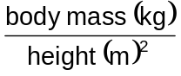
The figure below shows the effect of BMI on the relative risk of dying from cancer. Non-obese people with a BMI of 18.5–24.9 are assigned a baseline risk of 1.
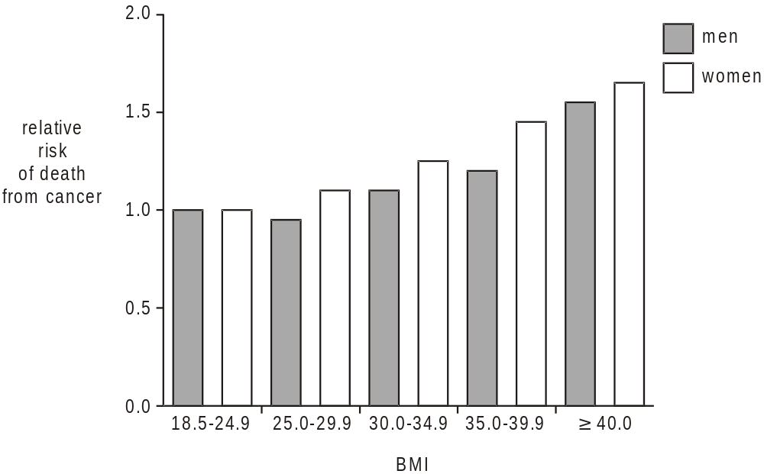
© National Obesity Forum, Reproduced by kind permission of the National Obesity Forum
(i) Calculate the BMI of a woman 1.7 m tall with a mass of 105 kg.

Answer = .........................................................
[2]

(ii) Use the figure above to explain the likelihood of this woman dying from cancer.
.........................................................................................................................
.........................................................................................................................
.........................................................................................................................
.........................................................................................................................
[2]
[Total 4 marks]

24. The table below shows a number of categories of disease, a definition of each category and one example of a disease that fits into each category.
Complete the table.
category | definition of disease category | one example
deficiency | diseases caused by poor diet | scurvy
................................. | diseases caused by a genetic fault  passed from the parents | cystic fibrosis
degenerative | ...............................................................  ...............................................................  ............................................................... | Huntington’s disease
infectious | diseases that are transmitted by a  pathogenic organism which invades the  body | ................................
................................. | diseases caused by changes to the mind | schizophrenia
physical | ...............................................................  ............................................................... | asthma
[Total 5 marks]

25. Epidemiology is the study of patterns of disease and the factors that affect their occurrence and spread.
State three ways in which members of the medical profession can use information about how diseases spread.
1 ...............................................................................................................................
..................................................................................................................................
2 ...............................................................................................................................
..................................................................................................................................
3 ...............................................................................................................................
..................................................................................................................................
[Total 3 marks]

26. The different parts of the gaseous exchange system, such as the bronchi, show structural adaptations to their functions. The diagram below shows a section through the wall of a bronchus as seen with a light microscope.
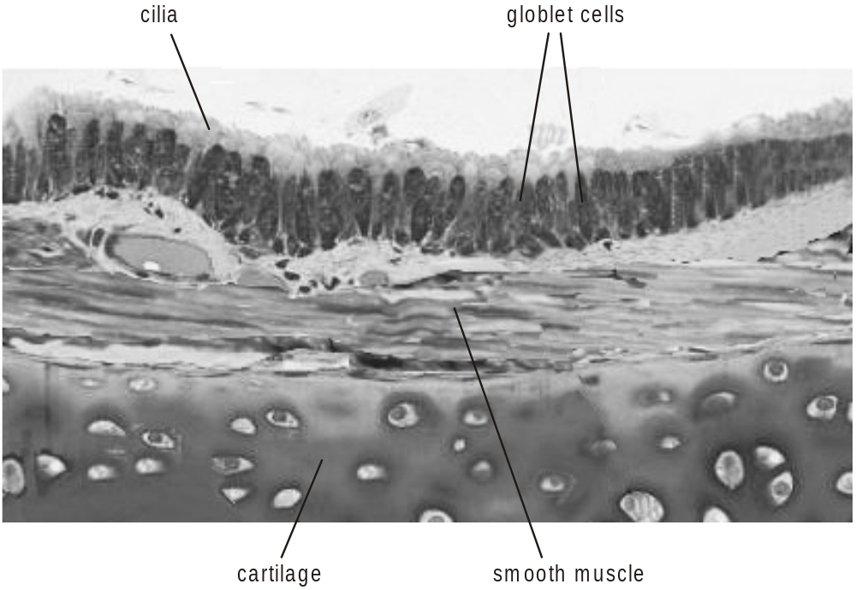

(a) (i) State one function for each of the following components of the bronchus wall.
goblet cell ...............................................................................................
................................................................................................................
cartilage .................................................................................................
................................................................................................................
[2]

(ii) State two ways in which the structure of the wall of the bronchus would be different in a long-term smoker.
1 .............................................................................................................
................................................................................................................
2 .............................................................................................................
................................................................................................................
[2]

(b) Gaseous exchange occurs across the walls of the alveoli.
Explain why the walls of the alveoli contain elastic fibres.
.........................................................................................................................
.........................................................................................................................
.........................................................................................................................
.........................................................................................................................
[2]

(c) One feature of the disease emphysema is that the alveoli lose their elasticity.
Explain the effects of this loss of elasticity on the gaseous exchange system of a person with emphysema.
.........................................................................................................................
.........................................................................................................................
.........................................................................................................................
.........................................................................................................................
.........................................................................................................................
.........................................................................................................................
.........................................................................................................................
.........................................................................................................................
[4]
[Total 10 marks]

27. The diagram below shows an artery lying on the surface of living heart muscle as seen by an instrument called an endoscope. The lumen of the artery has become narrowed at the point labelled Y.
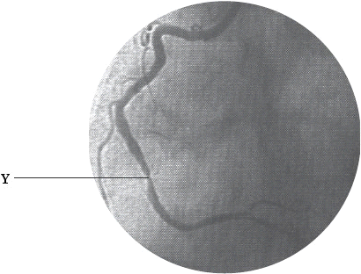
The Forum on Ischaemic Heart Disease.
Reproduced by kind permission of Dr Graham Jackson,
Cardiology Unit, Guy’s and St Thomas’ Hospital.
(i) Name the artery shown in the diagram.
.........................................................................................................................
[1]

(ii) Explain how the lumen of the artery has become narrowed at point Y.
.........................................................................................................................
.........................................................................................................................
.........................................................................................................................
.........................................................................................................................
[2]
[Total 3 marks]

28. (i) Suggest how doctors might treat a patient with narrowing of the arteries that supply the heart muscle.
.........................................................................................................................
.........................................................................................................................
.........................................................................................................................
.........................................................................................................................
[2]

(ii) Suggest two pieces of advice that a doctor might give to such a patient to try to reduce the likelihood of further narrowing of the arteries.
1 ......................................................................................................................
.........................................................................................................................
2 ......................................................................................................................
.........................................................................................................................
[2]
[Total 4 marks]

29. (a) Milk contains a number of important nutrients including:
• proteins which contain amino acids
• fats which contain fatty acids
• minerals.
Name two other groups of nutrients found in a balanced diet.
1 ......................................................................................................................
2 ......................................................................................................................
[2]

(b) Some amino acids are known as essential amino acids.
(i) State what is meant by the term essential amino acids.
................................................................................................................
................................................................................................................
[1]

(ii) Outline the functions of essential amino acids in the body.
................................................................................................................
................................................................................................................
................................................................................................................
................................................................................................................
[2]

(c) The photograph below shows a child with kwashiorkor, a form of protein energy malnutrition.
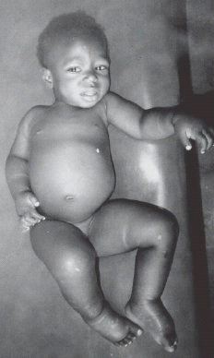
Reproduced by kind permission of Tom D Thacher,
MD, www.thachers.org

(i) Describe the symptoms of kwashiorkor.
................................................................................................................
................................................................................................................
................................................................................................................
................................................................................................................
................................................................................................................
................................................................................................................
[3]

(ii) Explain why the onset of this disease often occurs between the ages of six months and eighteen months.
................................................................................................................
................................................................................................................
................................................................................................................
................................................................................................................
[2]
[Total 10 marks]

30. The table below shows:
• the percentage of people with HIV/AIDS in different regions of the world at the end of 2002
• the number of new infections with HIV between 1999 and 2002 expressed as a percentage of those with HIV/AIDS at the end of 2002.
region | percentage of people with HIV/AIDS at the end of 2002 | number of new infections between 1999 and 2002 as % of those with HIV/AIDS at the end of 2002
East Asia and Pacific | 1 | 76
Eastern Europe and  Central Asia | 1 – 5 | 196
North Africa and  Middle East | 1 | 74
North America | 1 | 16
Sub-Saharan Africa | 15 – 39 | 52
Western Europe | 1 | 15

It has been suggested that HIV/AIDS is a greater problem in less economically developed regions than in more economically developed regions.
Describe the evidence in the table that supports this suggestion.
..................................................................................................................................
..................................................................................................................................
..................................................................................................................................
..................................................................................................................................
..................................................................................................................................
..................................................................................................................................
[Total 2 marks]

31. In this question, one mark is available for the quality of spelling, punctuation and grammar.
Explain why it is difficult to prevent the spread of HIV/AIDS and explain why the increase in the number of cases is so much higher in some parts of the world than in others.
[7]
Quality of Written Communication [1]
[Total 8 marks]

32. (a) Complete the following passage.
In October 2004, scientists announced successful trials of a malaria vaccine. The
vaccine was developed from proteins taken from the parasite, ......................................
falciparum. When the proteins enter the body they act as ......................................
which are recognised as foreign by the immune system. These foreign proteins activate
lymphocytes called T cells which then divide to increase in numbers. Some of these
newly cloned cells become ...................................... cells which attack infected cells in
the liver. Others become ...................................... cells which release a hormone-like
messenger molecule called a ...................................... . These molecules activate B
cells to divide and produce plasma cells. The B cells also produce
...................................... cells that stay in the body for a number of years. The result is
an immune system prepared to make a strong attack on the parasite when it enters the
body.
[6]

(b) Name the molecules, released by plasma cells, that attack the parasite when it enters the body.
.........................................................................................................................
[1]

(c) Suggest why it has been difficult to produce a malaria vaccine.
.........................................................................................................................
.........................................................................................................................
.........................................................................................................................
.........................................................................................................................
.........................................................................................................................
.........................................................................................................................
[3]
[Total 10 marks]

33. (a) The malarial parasite, Plasmodium, and its vector, the mosquito, are both eukaryotes.
The treatment and control of malaria is difficult because Plasmodium rapidly develops resistance to most anti-malarial drugs as do mosquitoes to insecticides. Also, vaccine production has proved to be very difficult. The B-cell responses induced by experimental vaccines are not yet very effective.
Explain
(i) the genetic basis of resistance in eukaryotes;
................................................................................................................
................................................................................................................
................................................................................................................
................................................................................................................
................................................................................................................
................................................................................................................
................................................................................................................
................................................................................................................
[5]

(ii) why producing an effective vaccine against Plasmodium has proved to be so difficult.
................................................................................................................
................................................................................................................
................................................................................................................
................................................................................................................
................................................................................................................
................................................................................................................
[3]

(b) A gene has been identified in several species of Plasmodium which codes for a small transmembrane protein.
A mutant form of P. berghei exists in which this protein is not produced. P. berghei infects mice. The mutants:
• develop normally in a mosquito and infect the salivary glands in numbers comparable to wild type parasites
• infect mouse liver cells but do not multiply
• do not infect red blood cells.
(i) Describe one mutation of this gene that could have occurred in P. berghei so that the encoded protein is not produced.
................................................................................................................
................................................................................................................
................................................................................................................
[2]

(ii) Suggest one reason why mutant P. berghei do not infect red blood cells.
................................................................................................................
................................................................................................................
................................................................................................................
................................................................................................................
[2]

(c) It has been suggested that Plasmodium with this mutation could be used as a ‘whole organism’ vaccine against malaria.
Mice were inoculated with different numbers of mutant Plasmodium and then given one or two ‘booster’ inoculations. Their protection against infection by wild-type Plasmodium was compared with that of mice that had not been inoculated. The results of the investigation are shown in the table below.
number of mutant Plasmodium |  |  | percentage of mice
in initial inoculation | in first booster  inoculation | in second booster  inoculation | resistant to infection by wild-type Plasmodium
50 000 | 25 000 | 25 000 | 100
10 000 | 10 000 | 10 000 | 100
10 000 | 10 000 | 0 | 70
0 | 0 | 0 | 0
With reference to the information in the table and in (b), comment on the use of this mutant Plasmodium as a ‘whole organism’ vaccine.
.........................................................................................................................
.........................................................................................................................
.........................................................................................................................
.........................................................................................................................
.........................................................................................................................
[3]
[Total: 15 marks]

34. The Royal Society for the Protection of Birds (RSPB) and the British Trust for Ornithology (BTO) carried out research into the declining populations of farmland bird species. In a study carried out from 1970 to 1998 they found that farmland bird species had decreased by up to 68% across rural areas of the UK.
(i) Changes in farming practices, such as the increased use of pesticides, are highlighted by the RSPB and BTO as possible causes of this decline in bird species.
Suggest how the increased use of pesticides could have caused this decline.
.........................................................................................................................
.........................................................................................................................
.........................................................................................................................
.........................................................................................................................
.........................................................................................................................
.........................................................................................................................
[3]

(ii) An increase in the number of predators, such as magpies and sparrowhawks, has also been suggested as a possible cause for the decline in the populations of farmland bird species.
Suggest why this may not be the cause.
.........................................................................................................................
.........................................................................................................................
.........................................................................................................................
.........................................................................................................................
[2]
[Total 5 marks]

35. The Human Immunodefficiency Virus (HIV) is spread by exchange of body fluids between an infected person and an uninfected person. This often occurs as a result of unprotected sexual intercourse. HIV / AIDS is categorised as an infectious disease.
Listed below are three other categories of disease.
(a) State one example of a disease that fits into each category.
mental disease ...............................................................................................
self-inflicted disease .......................................................................................
inherited disease ............................................................................................
[3]

The diagram below shows the percentage of people infected with HIV in different parts of the world at the end of 2002.
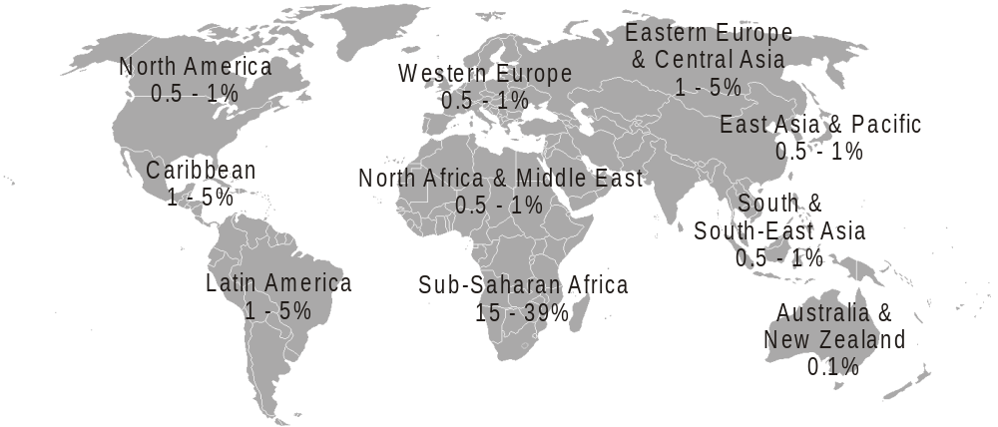
data from UNAIDS

(b) (i) Explain why it is useful to collect information, such as that shown in the diagram.
................................................................................................................
................................................................................................................
................................................................................................................
................................................................................................................
................................................................................................................
................................................................................................................
................................................................................................................
[3]

(ii) The percentage of people infected with HIV is much higher in Sub-Saharan Africa than in much of Europe.
Suggest why the percentages are so much higher in Sub-Saharan Africa.
................................................................................................................
................................................................................................................
................................................................................................................
................................................................................................................
[2]

(c) At present there is no cure for HIV/AIDs. Efforts to reduce the spread of HIV infection are centred on reducing the chances of a person carrying HIV passing it on to others.
Suggest how information gained from the Human Genome Project might be used to help reduce the spread of HIV.
.........................................................................................................................
.........................................................................................................................
.........................................................................................................................
.........................................................................................................................
.........................................................................................................................
[2]
[Total 10 marks]

36. The diagram below shows stages in the immune response to invading bacteria.
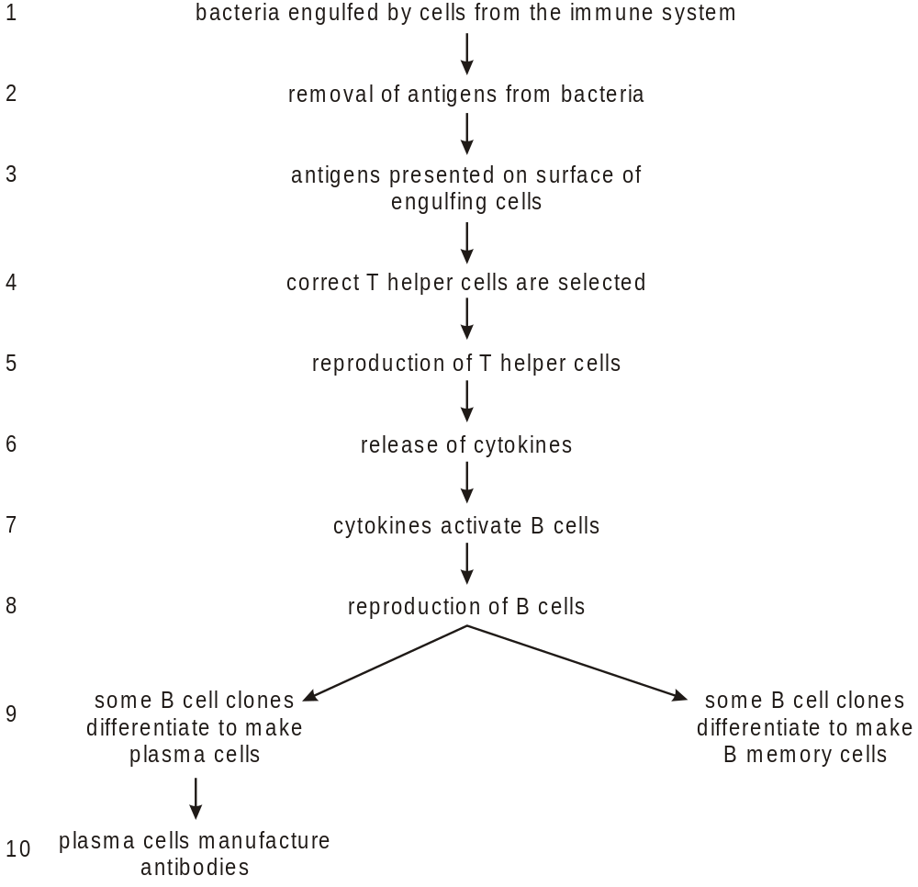

(i) Name the type of cell that engulfs the bacteria in stage 1.
.........................................................................................................................
[1]
(ii) Suggest how the antigens are removed from the bacteria in stage 2.
.........................................................................................................................
.........................................................................................................................
.........................................................................................................................
.........................................................................................................................
[2]

(iii) Explain how the correct T helper cells are selected in stage 4.
.........................................................................................................................
.........................................................................................................................
.........................................................................................................................
.........................................................................................................................
[2]
(iv) Name the type of cell division used for reproduction of the T helper cells in
stage 5.
.........................................................................................................................
[1]

(v) Explain the importance of B memory cells in immunity.
.........................................................................................................................
.........................................................................................................................
.........................................................................................................................
.........................................................................................................................
.........................................................................................................................
.........................................................................................................................
.........................................................................................................................
.........................................................................................................................
[4]
[Total 10 marks]

37. Describe how antibodies act on invading pathogens, such as bacteria or viruses.
..................................................................................................................................
..................................................................................................................................
..................................................................................................................................
..................................................................................................................................
..................................................................................................................................
[Total 2 marks]

38. Both Fig. 1 and Fig. 2 are photographs of lung tissue taken through a light microscope at the same magnification.
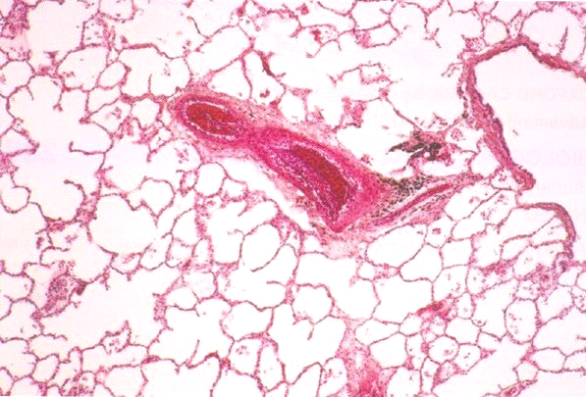
Fig. 1

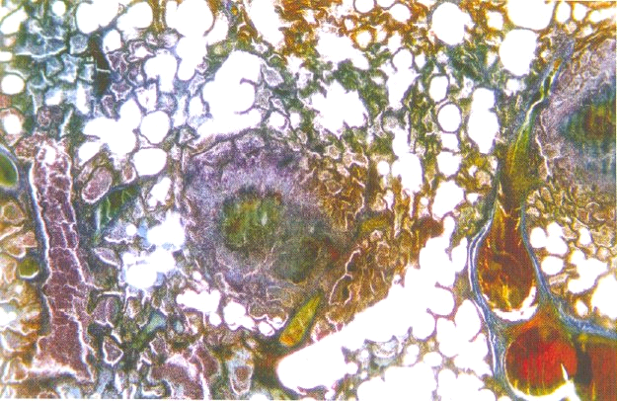
John Burbridge / Science Photo Library
Fig. 2
Fig. 1 shows healthy lung tissue.
Fig. 2 shows lung tissue damaged by tuberculosis.

(a) Name the organism that causes tuberculosis.
.........................................................................................................................
[1]
(b) Suggest how damage to lung tissue in tuberculosis, as seen in Fig. 2, is likely to affect a person with this disease.
.........................................................................................................................
.........................................................................................................................
.........................................................................................................................
.........................................................................................................................
.........................................................................................................................
[2]

(c) Outline the reasons why tuberculosis has not been eradicated.
.........................................................................................................................
.........................................................................................................................
.........................................................................................................................
.........................................................................................................................
.........................................................................................................................
.........................................................................................................................
.........................................................................................................................
.........................................................................................................................
.........................................................................................................................
.........................................................................................................................
.........................................................................................................................
.........................................................................................................................
[5]
[Total 8 marks]

39. (a) Name two diseases that may be caused by many years of cigarette smoking.
1 ......................................................................................................................
2 ......................................................................................................................
[2]

(b) In this question, one mark is available for the quality of use and organisation of scientific terms.
The diagram below shows three components inhaled as a result of smoking a cigarette.
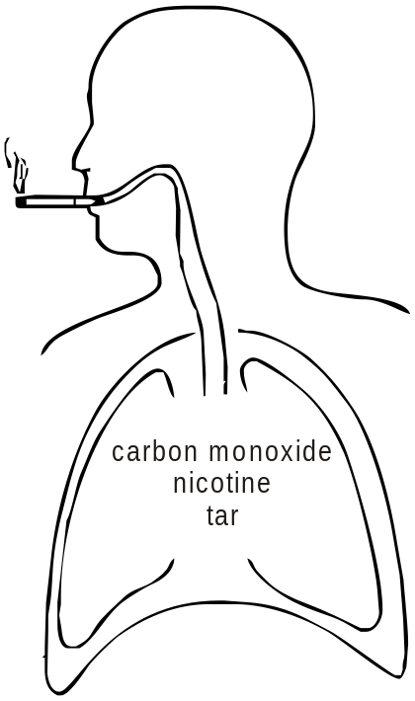
Describe the effects of these three components of cigarette smoke on the body.
[8]
Quality of Written Communication [1]
[Total 11 marks]

40. Haemolytic disease of the newborn can occur if red blood cells are broken down too rapidly.
This is caused by antibodies, produced by the mother, crossing the placenta into the fetal circulation.
Suggest how antibodies cause the breakdown of red blood cells in haemolytic disease of the newborn.
..................................................................................................................................
..................................................................................................................................
..................................................................................................................................
..................................................................................................................................
..................................................................................................................................
..................................................................................................................................
[Total 2 marks]

41. Researchers and medical practitioners calculate the ratio of the total blood cholesterol concentration (TC) to the concentration of cholesterol carried by one type of lipoprotein, called high density lipoprotein (HDL). This ratio is called the TC : HDL ratio.
The TC : HDL ratio and the resting systolic blood pressure are both factors which are associated with the risk of having coronary heart disease (CHD).
Systolic pressure is the pressure in the major distributing arteries when the left ventricle contracts.

The way in which both the TC : HDL ratio and the resting systolic blood pressure are associated with the risk of CHD, is shown in the figure below.
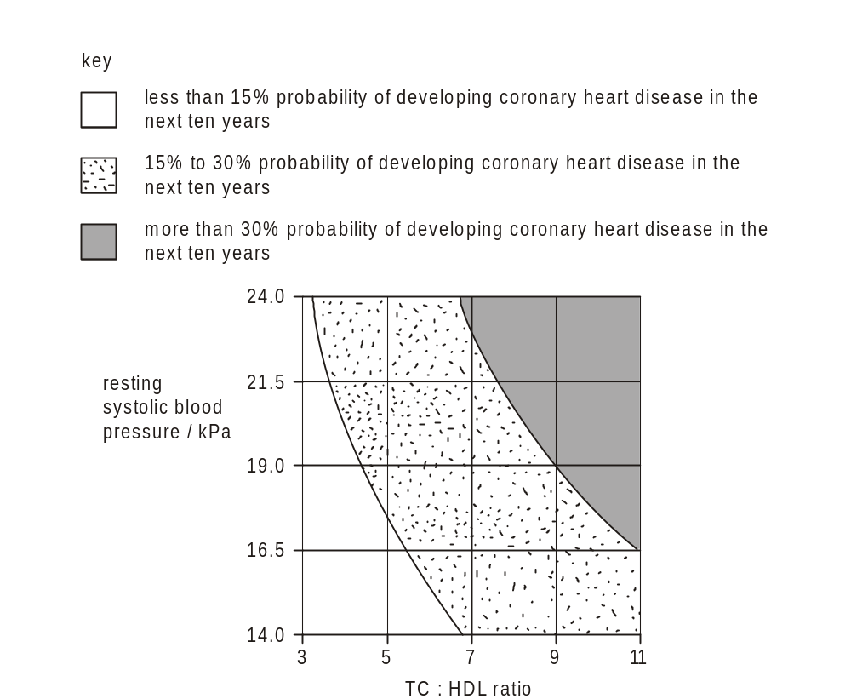

Using only the information above, describe the influence of the TC : HDL ratio and the resting systolic blood pressure on the risk of developing CHD.
..................................................................................................................................
..................................................................................................................................
..................................................................................................................................
..................................................................................................................................
..................................................................................................................................
..................................................................................................................................
..................................................................................................................................
[Total 3 marks]

42. Smoking is considered to be a disease. In 2004, in the UK, the Wanless Report recommended a change in emphasis in the way that the National Health Service tackles certain diseases, such as smoking and obesity.
(a) Name one category of disease which includes smoking and obesity.
.........................................................................................................................
[1]

(b) Both these diseases increase the risk of developing coronary heart disease (CHD). CHD is known as a multifactorial disease.
Suggest what is meant by the term multifactorial disease.
.........................................................................................................................
.........................................................................................................................
[1]

(c) Explain how cigarette smoke can increase the risk of developing CHD.
.........................................................................................................................
.........................................................................................................................
.........................................................................................................................
.........................................................................................................................
.........................................................................................................................
.........................................................................................................................
[3]

(d) Suggest reasons why the incidence of CHD is not the same in all parts of the world.
.........................................................................................................................
.........................................................................................................................
.........................................................................................................................
.........................................................................................................................
.........................................................................................................................
.........................................................................................................................
.........................................................................................................................
.........................................................................................................................
.........................................................................................................................
[4]

(e) The Wanless Report recommended greater emphasis on prevention rather than cure.
With reference to CHD, suggest what benefits this change in approach may bring.
.........................................................................................................................
.........................................................................................................................
.........................................................................................................................
.........................................................................................................................
.........................................................................................................................
.........................................................................................................................
[3]
[Total 12 marks]

43. A number of definitions are listed in the table below.
In the right hand column, write a term that best matches the definition in the left hand column. The first one has been done for you.
The type of B cell which secretes antibodies. | plasma cell
The term which refers to any organism that causes
infectious disease.
Diseases which cause a progressive deterioration of part
of the body.
The type of exercise that uses the heart and lungs to
provide oxygen for respiration in muscles.
The volume of air breathed in or out during a single
breath.
A term used to describe a disease that spreads across
continents.
[Total 5 marks]

44. During an immune response, phagocytic cells are attracted to the site of infection.
Describe the action of these phagocytic cells at the site of infection.
..................................................................................................................................
..................................................................................................................................
..................................................................................................................................
..................................................................................................................................
..................................................................................................................................
..................................................................................................................................
..................................................................................................................................
..................................................................................................................................
[Total 4 marks]

45. Sometimes the immune system overreacts and responds to otherwise harmless substances. This occurs in allergic reactions.
The diagram below shows the increase in the percentage of children with allergies. The figures were collected between 1975 and 2005 in the UK.
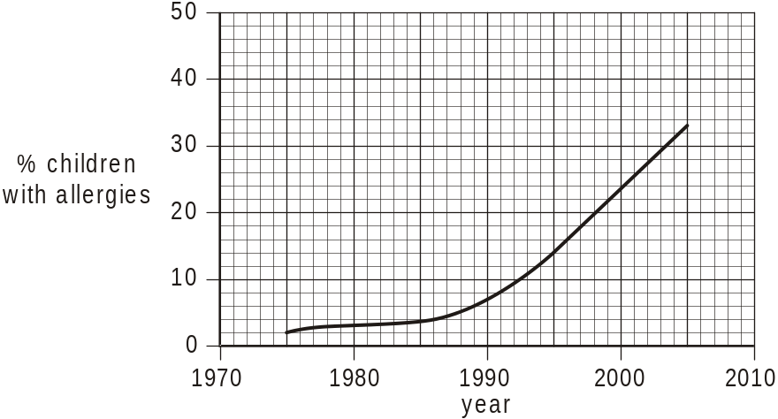

(i) Suggest one reason for the increase shown in the diagram.
.........................................................................................................................
[1]
(ii) Use the information in the diagram to estimate the percentage of children who are likely to have an allergy in 2010. Assume the rate of increase remains constant.
.........................................................................................................................
[1]
[Total 2 marks]

46. (i) Name the virus that leads to AIDS.
.........................................................................................................................
[1]

(ii) The virus infects and kills T helper cells in the immune system.
State three ways in which the lack of T helper cells will affect the functioning of the immune system.
1 ......................................................................................................................
.........................................................................................................................
2 ......................................................................................................................
.........................................................................................................................
3 ......................................................................................................................
.........................................................................................................................
[3]

(iii) State three ways in which this virus can be transmitted from person to person.
1 ......................................................................................................................
.........................................................................................................................
2 ......................................................................................................................
.........................................................................................................................
3 ......................................................................................................................
.........................................................................................................................
[3]
[Total 7 marks]

47. Papaya fruit are an important commercial crop in many tropical countries. The wild relatives of C. papaya are found in tropical South America.
(i) Explain the importance of keeping seeds of the wild relatives of commercial crop plants, such as papaya, in a seed bank.
.........................................................................................................................
.........................................................................................................................
.........................................................................................................................
.........................................................................................................................
.........................................................................................................................
.........................................................................................................................
[3]

(ii) Outline the main steps by which disease resistance could be selectively bred into commercially grown papaya.
.........................................................................................................................
.........................................................................................................................
.........................................................................................................................
.........................................................................................................................
.........................................................................................................................
.........................................................................................................................
[3]
[Total 6 marks]

48. Cholesterol molecules are transported in the blood as lipoproteins. Some lipoproteins are high density lipoproteins (HDLs) and others are low density lipoproteins (LDLs).
The liver regulates the blood cholesterol concentration.
A high blood cholesterol concentration indicates that a person’s health may be at risk.
Cholesterol also has many beneficial functions in the body.
Outline the functions of cholesterol in the body.
..................................................................................................................................
..................................................................................................................................
..................................................................................................................................
..................................................................................................................................
..................................................................................................................................
..................................................................................................................................
[Total 3 marks]

49. Suggest why the people were required not to eat before the blood test.
..................................................................................................................................
..................................................................................................................................
..................................................................................................................................
..................................................................................................................................
[Total 2 marks]

50. Radiation is one factor that can increase the chance of developing lung cancer.
Radon, a naturally occurring radioactive gas, is found in all rocks and soils. On average, radon contributes about 50% of the total radiation dose received by people.
Different areas of the UK have different levels of radon because of their rock and soil types.
Radon seeps out of soils and rocks into the air and may build up in enclosed spaces such as buildings.
Air containing an average concentration of 20 units of radon is considered to be a typical figure.
Air containing an average concentration of 200 units has been defined as a Threshold Level at which radon is considered to be a significant risk.
Research has linked exposure to radon with an increased risk of lung cancer. Smoking also increases the risk of lung cancer.
Some typical figures are shown in the table below.
 | estimated risk of developing lung cancer / %
radon level / arbitrary units | no exposure to cigarette smoke | smoker (15 cigarettes per day)
0 | 0.1 | 1.0
20 | 0.1 | 1.0
200 | 1.0 | 10.0

Using the data in the table,
(i) calculate by how much smoking increases the risk of developing lung cancer;
.........................................................................................................................
.........................................................................................................................
[1]

(ii) comment on the risks of radon and smoking on the development of lung cancer.
.........................................................................................................................
.........................................................................................................................
.........................................................................................................................
.........................................................................................................................
.........................................................................................................................
.........................................................................................................................
[2]
[Total 3 marks]

51. The diagram below shows the transmission cycle of the single-celled organism that causes malaria.
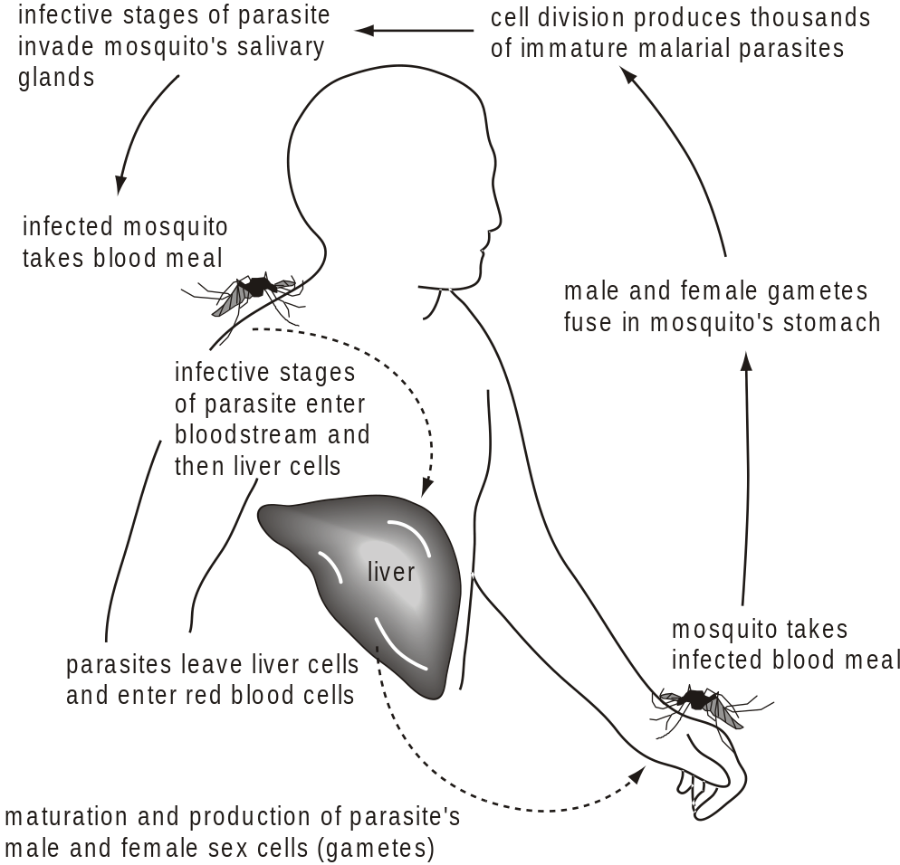
Adapted from Fosbery, R. Human Health and Disease, CUP 1997

(a) Use your knowledge and the information shown in the diagram above to complete the passage below.
Malaria is caused by a single-celled organism called .................................. . The
organism is transmitted from one person to another by female .............................
mosquitoes. A mosquito takes up the gametes of the malarial parasite when it
feeds on the blood of an ................................... person. Fertilisation occurs in the
mosquito’s stomach and the immature parasites reproduce. Infective stages of
the parasite migrate to the mosquito’s salivary glands. A new person becomes
infected when the mosquito takes another meal of ................................ . The
parasites enter the liver of the new victim where further reproduction takes place
before migrating to the red blood cells. When an organism, such as the mosquito,
is involved in transmission it is called a ............................. . The malarial parasite
can also be transmitted by .......................... ............................. .
[6]

(b) Describe two ways in which the transmission cycle of malaria can be disrupted.
1 ......................................................................................................................
.........................................................................................................................
2 ......................................................................................................................
.........................................................................................................................
[2]
[Total 8 marks]

52. Outline how substances such as benzpyrene affect the cells in the lungs.
..................................................................................................................................
..................................................................................................................................
..................................................................................................................................
..................................................................................................................................
..................................................................................................................................
..................................................................................................................................

[Total 3 marks]

53. State two symptoms which could alert someone to the possibility that they may have lung cancer.
symptom 1 ................................................................................................................
..................................................................................................................................
symptom 2 ................................................................................................................
..................................................................................................................................
[Total 2 marks]

54. Severe Acute Respiratory Syndrome (SARS) is a severe form of viral pneumonia. The disease was first described in China in November 2002. Within six weeks, 29 countries were affected. The number of cases in China was considered to be of epidemic proportions. The World Health Organisation called SARS ‘the first worldwide epidemic of the twenty-first century’.
Vaccination can provide protection against many diseases by inducing artificial active immunity.
(i) What is meant by the word artificial in the term artificial active immunity?
.........................................................................................................................
.........................................................................................................................
[1]

(ii) Describe how an effective vaccine can produce active immunity to a disease.
.........................................................................................................................
.........................................................................................................................
.........................................................................................................................
.........................................................................................................................
.........................................................................................................................
.........................................................................................................................
.........................................................................................................................
.........................................................................................................................
.........................................................................................................................
.........................................................................................................................
[4]

(iii) In 2003, scientists started working to produce a vaccine for SARS.
Explain how vaccination may be used as part of an eradication programme for diseases such as SARS.
.........................................................................................................................
.........................................................................................................................
.........................................................................................................................
.........................................................................................................................
.........................................................................................................................
.........................................................................................................................
[3]
[Total 8 marks]

55. The figure below shows the effect of increasing phosphate concentration on the growth of three plant species, which commonly grow as weeds amongst crops in the UK.
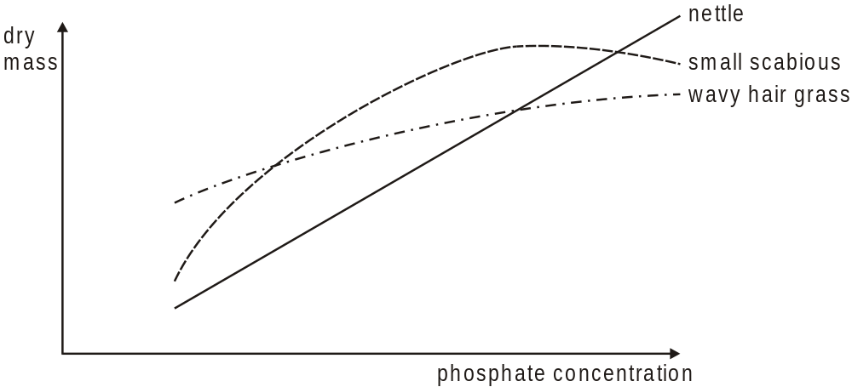
Adapted from an article by I.H.Rorison in New Phytologist /
1968 / Volume 67 / Issue 4 / Figure 2b (p.917)

Describe the effects of increasing phosphate concentration on the growth of these three plant species.
..................................................................................................................................
..................................................................................................................................
..................................................................................................................................
..................................................................................................................................
..................................................................................................................................
[Total 4 marks]

56. The smoke produced by burning tobacco leaves contains over 4000 different chemical compounds. Whilst some of these compounds may be harmless, others are addictive or may cause an increased risk of certain diseases.
(a) Name one compound in tobacco smoke that is addictive.
.........................................................................................................................
[1]

(b) Name two other harmful substances found in tobacco smoke. For each substance describe briefly the nature of the damage caused to the gaseous exchange system.
substance 1 ....................................................................................................
.........................................................................................................................
.........................................................................................................................
.........................................................................................................................
.........................................................................................................................
substance 2 ....................................................................................................
.........................................................................................................................
.........................................................................................................................
.........................................................................................................................
.........................................................................................................................
[5]
[Total 6 marks]

57. The diagram below shows the results of a study into the effects of smoking patterns in different socio-economic groups in the UK.
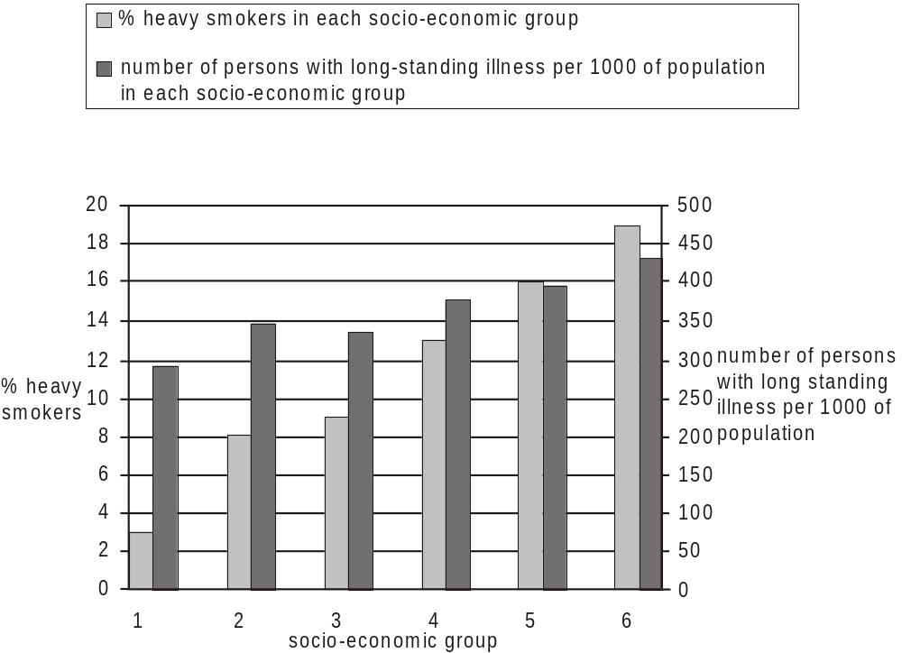

The socio-economic groups shown in the diagram are:
1 professional, e.g. doctors, teachers
2 semi-professional, e.g. employers, managers
3 skilled non-manual, e.g. computer technicians
4 skilled manual, e.g. plumbers, bricklayers
5 semi-skilled manual, e.g. painters, decorators
6 unskilled manual, e.g. labourers, delivery drivers

(i) With reference to the diagram above, describe the relationship between socio-economic group and the percentage of heavy smokers.
.........................................................................................................................
.........................................................................................................................
.........................................................................................................................
.........................................................................................................................
[2]

(ii) It has been suggested that the proportion of people suffering with long-term illness in each socio-economic group is directly linked to the percentage of heavy smokers in each group.
What evidence is there for or against this view?
.........................................................................................................................
.........................................................................................................................
.........................................................................................................................
.........................................................................................................................
.........................................................................................................................
.........................................................................................................................
[2]

(iii) Suggest two other factors that may contribute to the higher rates of long-term illness found in the groups of manual workers as compared to non-manual workers.
1 ......................................................................................................................
.........................................................................................................................
2 ......................................................................................................................
.........................................................................................................................
[2]
[Total 6 marks]

58. Body mass index (BMI) can be used to place people into categories according to their mass. BMI is calculated by the equation:
BMI = 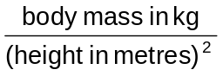
(a) People with a BMI of greater than 30 are classed as obese. State two causes of obesity.
1 ......................................................................................................................
.........................................................................................................................
2 ......................................................................................................................
.........................................................................................................................
[2]

As part of a long-term survey into the health of the nation, a random sample of the English population was selected every five years. The BMI of each member of the sample was calculated and the percentage of people fitting into each mass category was recorded. The results are shown in the table below.
 | year
BMI  category | 1980 | 1985 | 1990 | 1995 | 2000
underweight | 12 | 8 | 6 | 6 | 5
acceptable | 53 | 51 | 46 | 41 | 36
overweight | 28 | 32 | 34 | 36 | 39
obese | 7 | 9 | 14 | 17 | 20

(b) Describe the trends shown in the table above.
.........................................................................................................................
.........................................................................................................................
.........................................................................................................................
.........................................................................................................................
.........................................................................................................................
.........................................................................................................................
.........................................................................................................................
.........................................................................................................................
[4]
[Total 6 marks]

59. In this question, one mark is available for the quality of the use and organisation of scientific terms.
Obesity is one of the risk factors that increases the chance of coronary heart disease (CHD).
Explain how poor diet and obesity can affect the health of the heart.
[7]
Quality of Written Communication [1]
[Total 8 marks]

60. The diagram below is a representation of the three-dimensional structure of an antibody molecule. The shaded sections represent the heavy polypeptide chains. The diagram shows two antigen molecules attached to the antibody.
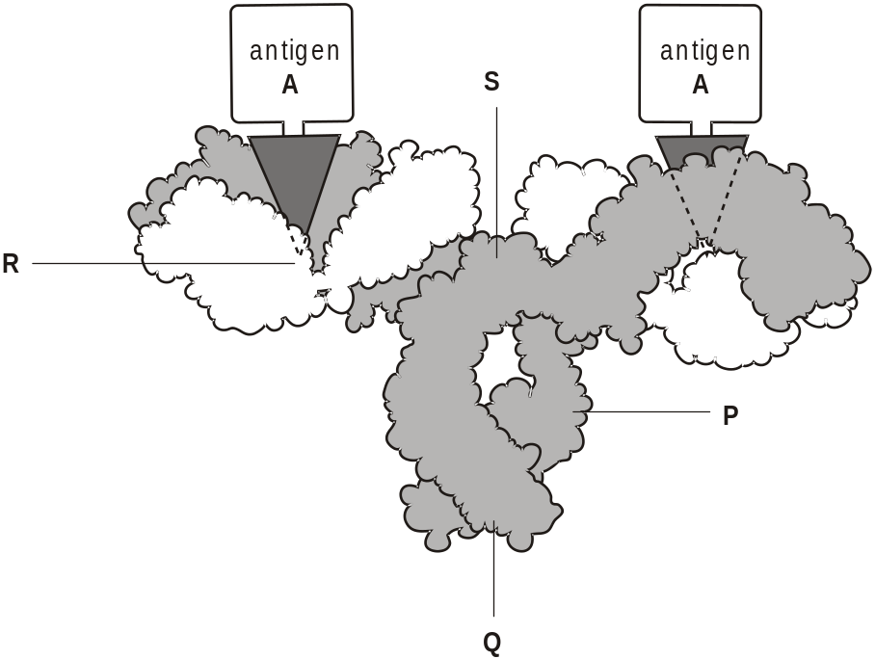
Anne White Biological Science Review 1993

(i) Select the letter P, Q, R or S, which identifies the position of a variable region of the antibody shown in the diagram above.
.........................................................................................................................
[1]

(ii) Explain why this antibody will bind only to antigen A.
.........................................................................................................................
.........................................................................................................................
.........................................................................................................................
.........................................................................................................................
[2]
[Total 3 marks]

61. MMR vaccine is a triple vaccine that contains antigenic material from measles, mumps and rubella. It gives 90% of all children who are vaccinated protection against measles. In the UK, the highest percentage of children in any year group that has been given the MMR vaccine is 92%.
(i) Calculate the percentage of children who were left unprotected against measles in the year that a 92% vaccination rate was achieved. Show your working.

Answer = ..................................................%
[2]

(ii) Measles has proved to be difficult to eradicate from any country and vaccination programmes have been less successful than with smallpox.
Suggest two reasons why measles has been more difficult to eradicate than
smallpox.
1 ......................................................................................................................
.........................................................................................................................
2 ......................................................................................................................
.........................................................................................................................
[2]
[Total 4 marks]

62. Fats in the diet provide the two essential fatty acids, linoleic acid and linolenic acid.
(a) Give one reason why these two fatty acids must be present in the diet.
.........................................................................................................................
.........................................................................................................................
[1]

A 25 year old woman is concerned that she may be eating too much saturated fat.
She discovers that there are Dietary Reference Values (DRVs) for fats. These include:
• total fat in the diet should not be greater than 35% of the total energy intake per day
• of this no more than 10% should be saturated fat.
She calculates that her total energy intake should be 8 830 kJ per day.
Each gram of fat provides 37 kJ.

(b) Calculate the maximum mass of fat in grams that the woman could consume if she is not to exceed the DRV for total fat in the diet.
Show your working and express your answer to the nearest whole number.

Answer ........................... g
[2]

(c) Explain the reasons for limiting the quantity of fat in the diet.
.........................................................................................................................
.........................................................................................................................
.........................................................................................................................
.........................................................................................................................
.........................................................................................................................
.........................................................................................................................
.........................................................................................................................
.........................................................................................................................
[4]

The woman decided to find out whether it is healthier to eat meat or fish. She compared the composition of mackerel (fish) and stewing steak (meat).
Some of the information that she found is summarised in the table below.
 | mass per 100g
nutrient | mackerel (fish) | stewing steak (meat)
protein/g | 18.7 | 30.9
vitamin A/μg | 45.0 | 0.0
vitamin D/μg | 25.0 | 0.0
calcium/mg | 11.0 | 15.0
iron/mg | 0.8 | 3.0
Data from ‘Food Tables and Labelling’, pp.32 and 33; 56 and 57, by A. E. Bender and D. A. Bender.
Published by Oxford University Press, 1999 (ISBN 0 19 832815 X).

(d) Explain, using the data in the table, the advantages and disadvantages for the health of the young woman of including mackerel in her diet instead of stewing steak.
.........................................................................................................................
.........................................................................................................................
.........................................................................................................................
.........................................................................................................................
.........................................................................................................................
.........................................................................................................................
.........................................................................................................................
.........................................................................................................................
.........................................................................................................................
[4]
[Total 11 marks]

63. Most children have antibodies to measles in their bloodstream at birth, giving them a natural immunity. The concentration of these antibodies decreases quite quickly after birth. Between the ages of about 6 to 12 months the concentration is low enough to make children susceptible to measles.
(a) (i) State the term given to the type of natural immunity described above.
................................................................................................................
[1]

(ii) State how antibodies to measles come to be present in children at birth.
................................................................................................................
................................................................................................................
[1]

A two year old child, who had not been vaccinated against measles, became infected with the disease. The concentration of antibodies specific to measles was measured in samples of blood taken at intervals of time for the following ten years. The results for the first eight weeks of this study are shown in the graph below.
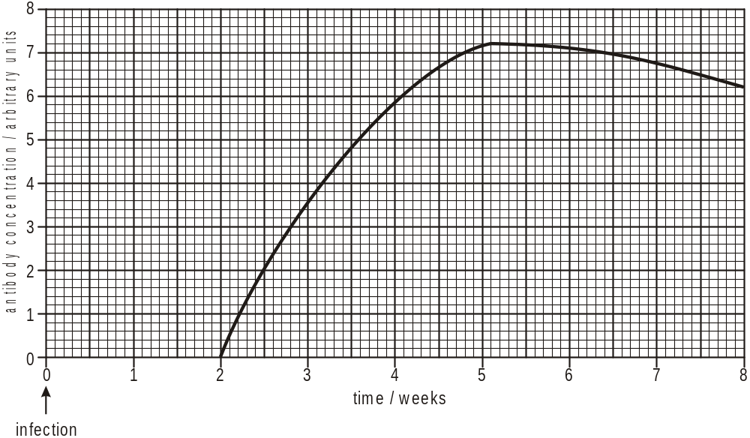

(b) State the name of the type of cell that produces antibodies.
.........................................................................................................................
[1]

(c) Explain why there is a delay between the time of infection and the first appearance of antibodies in the blood.
.........................................................................................................................
.........................................................................................................................
.........................................................................................................................
.........................................................................................................................
.........................................................................................................................
.........................................................................................................................
[3]

(d) This child is unlikely to develop the symptoms of measles if exposed to the pathogen again.
Explain why.
.........................................................................................................................
.........................................................................................................................
.........................................................................................................................
.........................................................................................................................
.........................................................................................................................
[2]

(e) Some children fail to respond to the measles vaccine when it is given too early, for example at or before 6 months of age.
Suggest why this is the case.
.........................................................................................................................
.........................................................................................................................
.........................................................................................................................
.........................................................................................................................
.........................................................................................................................
[2]
[Total 10 marks]

64. People in many countries, especially in Africa and South-East Asia, are at high risk of acquiring malaria.
Blood collected from a person known to have malaria was examined in an electron microscope. The diagram below shows a drawing made from an electron micrograph of a red blood cell infected by malarial parasites.
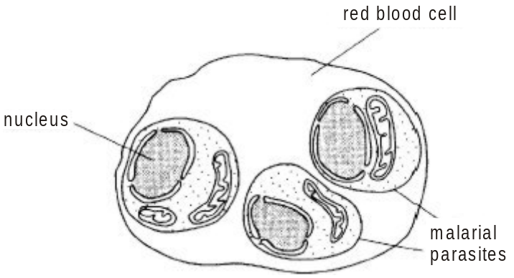

(a) State the name of the organism that causes malaria.
.........................................................................................................................
[1]

(b) Explain how an infected person is likely to have acquired malaria.
.........................................................................................................................
.........................................................................................................................
.........................................................................................................................
.........................................................................................................................
.........................................................................................................................
[3]

(c) In this question, one mark is available for the quality of written communication.
Outline the problems that are associated with controlling the spread of malaria.
(Allow one and a half lined pages).
[8]
Quality of Written Communication [1]
[Total 13 marks]

65. The table below shows the death rates from coronary heart disease (CHD) of men and women between the ages of 35 and 74 for some European countries. It also shows the prevalence of cigarette smoking among men and women of all ages in those countries. The prevalence of smoking is the percentage of men and women who smoke cigarettes every day.
 | deaths from CHD/  deaths per 100 000 |  | prevalence of  smoking/%
non-Mediterranean countries | men | women | men | women
Latvia | 321 | 107 | 54 | 24
Russian Federation | 459 | 153 | 70 | 27
United Kingdom | 121 | 40 | 37 | 35
Finland | 134 | 45 | 32 | 24
Czech Republic | 210 | 70 | 37 | 25
Hungary | 243 | 81 | 46 | 34
Mediterranean countries
Greece | 200 | 29 | 64 | 40
Italy | 116 | 39 | 33 | 19
Spain | 91 | 30 | 36 | 31
France | 85 | 21 | 37 | 27

(a) Suggest one reason why health authorities are especially concerned about the death rates from CHD for people in the 35 to 74 age group.
.........................................................................................................................
.........................................................................................................................
.........................................................................................................................
[1]

(b) Using only the information given in the table, explain whether or not the following hypotheses are supported by the data.
You should quote data from the table in support of your answers.
(i) Mediterranean countries have lower death rates from CHD than non-Mediterranean countries.
supported or not supported ....................................................................
explanation .............................................................................................
................................................................................................................
................................................................................................................
................................................................................................................
................................................................................................................

(ii) Men are more at risk of CHD than women.
supported or not supported ....................................................................
explanation .............................................................................................
................................................................................................................
................................................................................................................
................................................................................................................
................................................................................................................

(iii) Death rates from CHD are highest in countries with the highest prevalence of smoking.
supported or not supported ....................................................................
explanation .............................................................................................
................................................................................................................
................................................................................................................
................................................................................................................
................................................................................................................
[5]
[Total 6 marks]

66. A 50 year old man who regards himself as ‘in good health’ was asked by an insurance company to answer a series of questions about his health.
Here are some of his answers to the questions:
• smoke 20 cigarettes a day
• drink at least 8 pints of beer a week - most on Saturday evenings
• play football in the park on Sundays
• drive to work
• spend most evenings at home watching television
• rarely eat fresh fruit and vegetables
• father died of a heart attack at age 45.

Use the answers above to explain the statement ‘health is more than simply the absence of disease’.
..................................................................................................................................
..................................................................................................................................
..................................................................................................................................
..................................................................................................................................
..................................................................................................................................
..................................................................................................................................
..................................................................................................................................
..................................................................................................................................
..................................................................................................................................
[Total 3 marks]

67. The following passage is taken from a medical encyclopaedia.
“Smokers may develop two serious conditions. Firstly they may experience breathlessness, wheezing and a cough which develops as sputum is produced. As the smoker ages, the condition may become permanent and disable the smoker. This can be associated with the second condition. Symptoms may include a barrel-shaped chest, an oxygen deficiency that limits the possibility of exercise and a blueness of the skin. If the condition advances, oxygen may need to be supplied through a mask.” -
Name the two medical conditions described in the passage.
1 ................................................................................................................................
2 ...............................................................................................................................
[Total 2 marks]

68. (a) The diagram below shows a cross section of a coronary artery from a patient who had a heart attack.
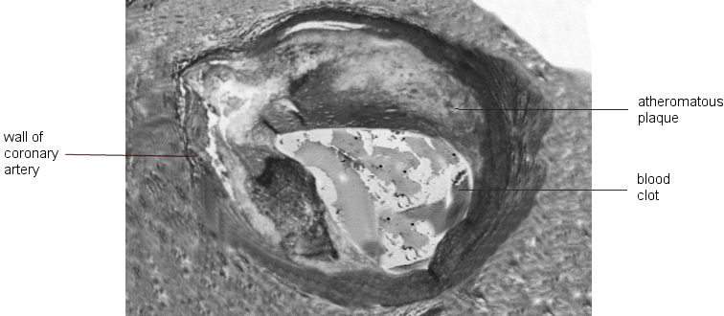

Describe how changes in the walls of coronary arteries make it likely that a blood clot will develop.
.........................................................................................................................
.........................................................................................................................
.........................................................................................................................
.........................................................................................................................
.........................................................................................................................
[3]

(b) Outline how nicotine and carbon monoxide in cigarette smoke may increase the risks of atherosclerosis and blood clotting.
.........................................................................................................................
.........................................................................................................................
.........................................................................................................................
.........................................................................................................................
.........................................................................................................................
.........................................................................................................................
[3]
[Total 6 marks]

69. Fig. 1 is a diagram that shows the origin and maturation of lymphocytes.
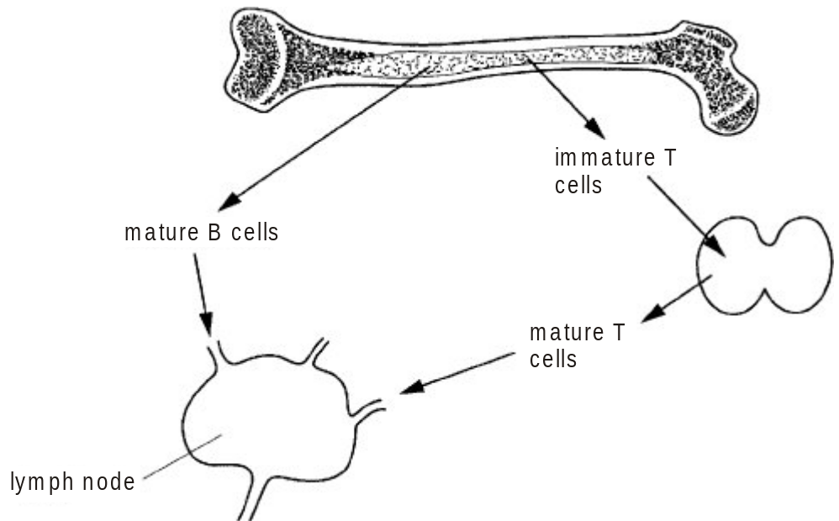
Fig. 1

Fig. 2 shows the changes that occur to B and T lymphocytes during an infection by a pathogen, such as a virus.
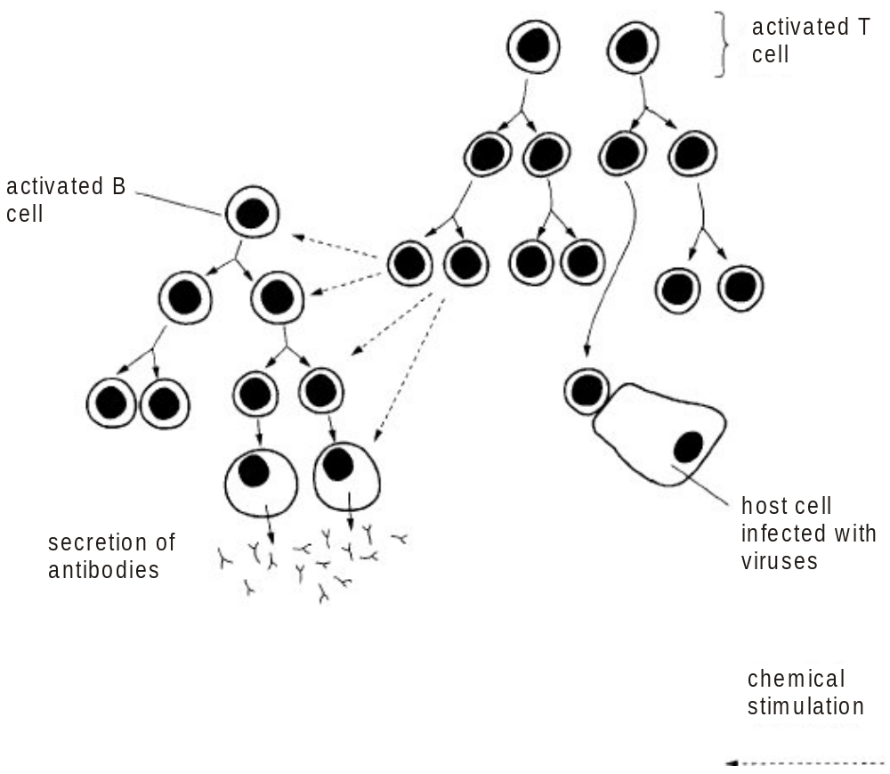
Fig. 2

Complete the following passage using the most appropriate terms.
The cells of the immune system originate from .......................... ...............................
where stem cells divide by mitosis to produce cells that differentiate into lymphocytes
and ..................................... .
Immature T lymphocytes migrate to the ................................. gland where they mature.
Mature B lymphocytes and mature T lymphocytes circulate and enter lymph nodes.
During an immune response some B lymphocytes differentiate into ..............................
................................. and secrete ................................. .
[Total 5 marks]

70. Fig. 1 is a diagram that shows the origin and maturation of lymphocytes.
Fig. 1

Fig. 2 shows the changes that occur to B and T lymphocytes during an infection by a pathogen, such as a virus.
Fig. 2

In this question, one mark is available for the quality of written communication.
Describe the changes that occur to T lymphocytes during an immune response. Explain the roles of T lymphocytes in fighting an infection by a pathogen, such as a virus.
You may use information from Fig. 2 in your answer.
(Allow one and a half lined pages).
[7]
Quality of Written Communication [1]
[Total 8 marks]

71. HIV is transmitted in a variety of ways.
In the UK, most of the HIV infections reported to the Communicable Disease Surveillance Centre (CDSC) have occurred as a result of sex between men.
Describe three ways in which HIV is transmitted, other than during sexual activity.
1 ...............................................................................................................................
..................................................................................................................................
2 ...............................................................................................................................
..................................................................................................................................
3 ...............................................................................................................................
..................................................................................................................................
[Total 3 marks]

72. HIV is transmitted in a variety of ways.
In the UK, most of the HIV infections reported to the Communicable Disease Surveillance Centre (CDSC) have occurred as a result of sex between men.
The CDSC collects statistics on HIV/AIDS and estimates the total number of people who are infected with HIV. This increases in the UK each year and in 2002, the CDSC estimated the number to be about 33 500. It also estimated that 30% of these people were not diagnosed.
The graph below shows the numbers of new HIV and AIDS diagnoses and deaths in those infected through sex between men in the UK between1985 and 2001.
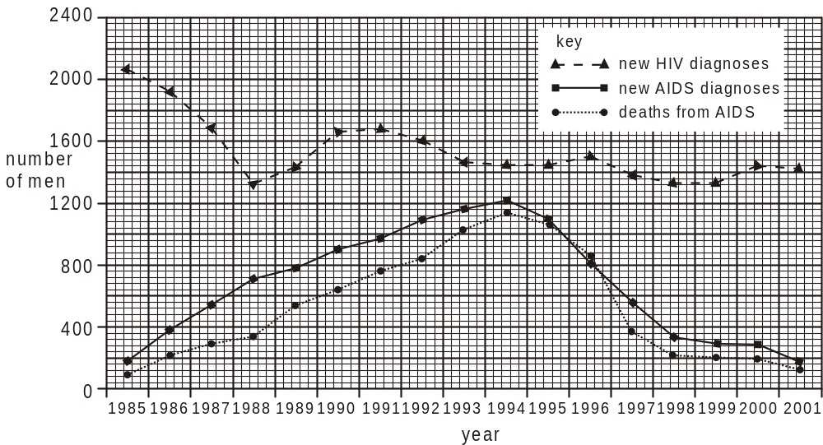

(i) Using the data in the graph, describe the changes that have occurred in the numbers of men diagnosed with HIV between 1985 and 2001.
.........................................................................................................................
.........................................................................................................................
.........................................................................................................................
.........................................................................................................................
.........................................................................................................................

(ii) Explain the decrease in number of men who have been diagnosed with AIDS and who have died from HIV/AIDS since 1994.
.........................................................................................................................
.........................................................................................................................
.........................................................................................................................
.........................................................................................................................
.........................................................................................................................

(iii) Using the data in the graph, explain why the number of people infected with HIV in the male homosexual population in the UK is increasing.
.........................................................................................................................
.........................................................................................................................
.........................................................................................................................
.........................................................................................................................
.........................................................................................................................
[Total 6 marks]

